**Js notes**

**Basics of Programming in JavaScript**

**Primitive**

In [JavaScript](https://developer.mozilla.org/en-US/docs/Glossary/JavaScript), a **primitive** (primitive value, primitive data type) is data that is not an [object](https://developer.mozilla.org/en-US/docs/Glossary/Object) and has no [methods](https://developer.mozilla.org/en-US/docs/Glossary/Method) or [properties](https://developer.mozilla.org/en-US/docs/Glossary/Property/JavaScript). There are 7 primitive data types:

* [string](https://developer.mozilla.org/en-US/docs/Glossary/String)
* [number](https://developer.mozilla.org/en-US/docs/Glossary/Number)
* [bigint](https://developer.mozilla.org/en-US/docs/Glossary/BigInt)
* [boolean](https://developer.mozilla.org/en-US/docs/Glossary/Boolean)
* [undefined](https://developer.mozilla.org/en-US/docs/Glossary/Undefined)
* [symbol](https://developer.mozilla.org/en-US/docs/Web/JavaScript/Reference/Global_Objects/Symbol)
* [null](https://developer.mozilla.org/en-US/docs/Glossary/Null)

Most of the time, a primitive value is represented directly at the lowest level of the language implementation.

All primitives are immutable; that is, they cannot be altered. It is important not to confuse a primitive itself with a variable assigned a primitive value. The variable may be reassigned to a new value, but the existing value cannot be changed in the ways that objects, arrays, and functions can be altered. The language does not offer utilities to mutate primitive values.

Primitives have no methods but still behave as if they do. When properties are accessed on primitives, JavaScript auto-boxes the value into a wrapper object and accesses the property on that object instead. For example, "foo".includes("f") implicitly creates a [String](https://developer.mozilla.org/en-US/docs/Web/JavaScript/Reference/Global_Objects/String) wrapper object and calls String.prototype.includes() on that object. This auto-boxing behavior is not observable in JavaScript code but is a good mental model of various behaviors — for example, why "mutating" primitives does not work (because str.foo = 1 is not assigning to the property foo of str itself, but to an ephemeral wrapper object).

* **Hello world program**

(`) back tick can be used instead of ‘’ or ’

` use in string

Semicolon good practice

// for commenting

console.log

prints anything on console

// console.log

// prints anything on console

console.log ("hello world");

first program

* **Declare variable using var**

Use semicolon to store string 9in console bracket

Declare a variable

Use var

Or change var

var firstname = "SHEHROZ";

console.log('first name');

don’t use semicolon for var name in console box

firstname = "shehroz";

console.log(firstname);

firstName = "bilal"

console.log(firstname)

if we not define var the error will occur and two-time shehroz will be printed because one var name is changed to eliminate that kind of mistakes we ‘use strict’ so console can gives us errors

"use strict";

For eliminating mistakes

"use strict";

// intro to variables

// variables can store some information

// we can use that information later

// we can change that information later

// declare a variable

var firstName = "Harshit";

// use a variable

console.log(firstName);

// change value

firstName = "Mohit";

console.log(firstName);

code for declaring variable

* **More about variable**

rule of naming variable?

var 1value ="shehroz"

console.log(1value)

Cannot be no and cannot use no in var start

No spaces and other symbols as well

We can only use $ and _ symbols in var

"use strict";

// rules for naming variables

// you cannot start with number

// example :-

// 1value (invalid)

// value1 (valid)

var value = 2;

console.log (value + 10);

console.log (value - 1);

console.log (value * 2);

console.log (value** 3);

console.log (value /2);

console.log(value);

// you can use only undersore _ or dollar symbol

// first_name (valid)

// _firstname (valid)

// first$name (valid)

// $firstname (valid)

// you cannot use spaces

// var first_name = "harshit"; // snake case writing

// var firstName = "harshit"; // camel case writing

// first name (invalid)

// convention

// start with small letter and use camelCase

Code for rules of declaring var

* **Let keyword**

Use let keyword to initailize variable instead of var keyword

var firstname = "shehroz"

console.log(firstname)

var firstname = "bilal"

 console.log(firstname)

no error

 let firstname = "shehroz"

console.log(firstname)

let firstname = "bilal"

 console.log(firstname)

error occurs

If we use var two times for same name var it wil produce no error but when we use let it will produce error(“let” increases the uniquness of that variablevar

// let keyword

// declare variable with let keyword

let firstName = "harshit";

firstName = "Mohit";

console.log(firstName);

// block scope vs funtion scope (covered later in this video)

Using let keyword in code

* Const

Value which cannot be changed using keyword “const”

Any operation can be performed on constant

// declare constants

const pi = 3.14;

// pi = 5634; //cannot be changed

console.log(pi);

* **String Indexing**

Space ki bhi length count hogi

“length “ keyword sa length maloom kar sakta ha

If length of string is unknown than it could be found by length -1

let firstName = "hgdskfhbkjsddlihjgfhj.lhsfljhlsha;hjalkfjlhjalsh";

console.log (firstName.length);

console.log (firstName.length-1);

to find length

let firstName = "hgdskfhbkjsddlihjgfhj.lhsfljhlsha;hjalkfjlhjalsh";

console.log(firstName[13]);

console.log(firstName[firstName.length-1]);

to find character on index

// String indexing

let firstName = "harshitdfjakldsfdf";

//  h    a   r   s   h   i   t

//  0    1   2   3   4   5   6

// console.log(firstName[0]);

// length of string

// firstName.length

console.log(firstName.length);

console.log(firstName[firstName.length-2]);

// last Index : length - 1

Code for string indexing

* **Useful string methods**

Trim,uppercase,lowercase and slice

. strings are immutable(cannot be changed only create new as original strings}

. trim remove extra space in string .trim will be a new string it would not change the given string

The new string can be print by initializing new variable.

let firstName = "         shehroz        ";

console.log(firstName); // will be printed with spaces

console.log(firstName.length); //  spaces will be counted

let newString= firstName.trim(); //should be saved in new variable

console.log(firstName); //will not be trimed we have to save trim in  variable

console.log(newString);

console.log(newString.length);

console.log(firstName.trim()); //or could be printed like that

using trim

let firstName = "shehroz";

let newString = firstName.toUpperCase();

console.log(newString);

console.log(firstName.toUpperCase());//or could be printed like that

using uppercase

let firstName = "SHEHROZ";

let newString = firstName.toLowerCase();

console.log(newString);

console.log(firstName.toLowerCase());//or could be printed like that

using lowercase

let firstName = "SHEHROZ";

let newString = firstName.slice(1);

let newString2 = firstName.slice(2,firstName.length-1);

console.log(newString);

console.log(newString2);

console.log(firstName.slice(1)); //or could be printed like that

console.log(firstName.slice(2,firstName.length-1)); //or could be printed like that

using slice

* **Types of operator**

“typeof” keyword is used to find the type of variable

>convert no to string (novar+””)

age = age+"";

>convert string to no(+strinvar)

firstName = +firstName

// typeof operator

// data types (primitive data types)

// string "harhit"

// number 2, 4, 5.6

// booleans

// undefined

// null

// BigInt

// Symbol

// let age = 22;

// let firstName = "harshit";

// // console.log(typeof age);

// // 22 -> "22"

// // convert number to string.

// age = age + "";

// console.log(typeof(age)); "22"

// // convert string to number.

// let myStr = +"34";

// console.log(typeof myStr);

// let age = "18";

// age = Number(age);

// console.log(typeof age);

Types of operator code

* **String concatenation**
* let str1 = "shehroz";
* let str2 ="bilal";
* let fullName = str1+" "+str2  //"" to add space
* console.log(fullName);

>if we had to enter space b/w to strings than (str1+””+str2)

// string concatenation

let string1 = "17";

let string2 = "10";

let newString = +string1 + +string2;

console.log(typeof newString);//no using converting string

console.log(newString);

newString = string1 + " "+ string2//concatenation

console.log(typeof newString);

console.log(newString);

concattenation

* **Template Strings**

Using backtic(``) and ${varname} making a string

// template string

let age = 22;

let firstName = "harshit"

// "my name is harshit and my age is 22 "

// let aboutMe = "my name is " + firstName + " and my age is " + age;

let aboutMe = `my name is ${firstName} and my age is ${age}`

console.log(aboutMe);

//my code

// let age =20;

// let firstName = "shehroz";

// let lastName = "bilal";

// // let aboutme = " my name is "+firstName+" " +lastName + " my age is "+age;

// let aboutme=` my name is ${firstName} ${lastName} my age is ${age} `;

// console.log(aboutme);

Code for string template

* **Null, undefined, BigInt, typeof**

let myVariable = null;

console.log(myVariable);

myVariable = "harshit";

console.log(myVariable, typeof myVariable);

console.log(typeof null);

// bug , error

**>null don’t means zerotype of null is object which is a bug or error**

let firstName;//undefined because no value assigned to variable

console.log(typeof firstName);

firstName = "Harshit";

console.log(typeof firstName, firstName);//string after assigning value

**>** undefined: when you don”t asign avalue to variable

// BigInt

let myNumber = BigInt(12);

let sameMyNumber = 123n;// n  for bigint

// console.log(myNumber);

// console.log(Number.MAX_SAFE_INTEGER); //range of int in js

console.log(myNumber+ sameMyNumber); //if we want to add two no types should be same

>int has some range in n js & to enter no above this range we use bigint(ex:123n(“n” is bigint)or bigint(123))

// undefined

// null

let firstName;//undefined because no value assigned to variable

console.log(typeof firstName);

firstName = "Harshit";

console.log(typeof firstName, firstName);//string after assigning value

let myVariable = null;

console.log(myVariable);

myVariable = "harshit";

console.log(myVariable, typeof myVariable);

console.log(typeof null);

// bug , error

// BigInt

let myNumber = BigInt(12);

let sameMyNumber = 123n;// n  for bigint

// console.log(myNumber);

// console.log(Number.MAX_SAFE_INTEGER); //range of int in js

console.log(myNumber+ sameMyNumber); //if we want to add two no types should be same

//my code

// let firstName;

// console.log(typeof firstName,firstName);

// firstName = "shehroz";

// console.log(typeof firstName,firstName);

// let firstName = null;

// console.log(typeof firstName);

// let number = 784652678687287873287;//wil print wrong because itis out of range

// number = 123;

// console.log(number);

// let number1 = 784652678687287873287n;

// console.log(number1);

// let number2 = BigInt(784652678687287873287);

// console.log(number2);

// console.log(Number.MAX_SAFE_INTEGER);

// console.log(number2+number1);

// console.log(number+number1);//it will make error type does not match

code

* **Booleans and Comparison Operator**

>comparison operators(<,>,>=,<=,==(can compare no and no in string),===(check for same datatype),!= (can compare no and no in string),!== (check for same datatype))

>Boolean(true, false)

// booleans & comparison operator

// booleans

// true, false

let num1 = 7;

let num2 = "7";

console.log(num1<num2);

// == vs ===

 console.log(num1 === num2);

// != vs !==

 console.log(num1 !== num2);

// //my code

// let no1 = 7;

// let no2 = "8";

// console.log(no1>=no2);//operators

// console.log(no1<=no2);//operators

// console.log(no1>no2);//operators

// console.log(no1<no2);//operators

// console.log(no1==no2);//any dt

// console.log(no1===no2);//=== checks with dt

// console.log(no1!=no2);//compare any dt

// console.log(no1!==no2);//!== checks with dt

* Truthy and Falsey Values & else If statement

>Falsy values (false,0,null,undefined,”” or empty braces)

Above mention values for variables are counted as false

>truty(any value other than falsey values are truthy like “abd”,1to-1)

>if and else condition also included

// truthy and falsy values

// falsy values

// false

// ""

// null

// undefined

// 0

// if else condition

let age = 17;

if(age>=18){

    console.log("User can play ddlc");

}else {

    console.log("User can play mario");

}

let num = "12";

if(num%2===0){

    let number = num%2   //% for reminder

    console.log(number, typeof number);

    console.log("even");

}else{

    console.log("odd");

}

// falsy values

// false

// ""

// null

// undefined

// 0

// truthy

// "abc"

// 1, -1

let firstName= 0;

if(firstName){

    console.log(firstName);

}else{

    console.log("firstName is kinda empty");

}

// //mu code

// let age =1;

// if(age>=18){

//     console.log("eligible for game");

// }else{

//     console.log("chal bhag");

// }

// console.log(12%5);/

Code for falsy and truthy and if&else condition

* **Ternary Operator**

>if we have to choose b/w two things we can use ternary operastor instead of if else

>ternary symbolization: condition? choice 1 : choice2 .if condition true than it will print choice 1 after ? & if condition false than it will choose choice 2 after colon

let age= 2;

let drink;

if (age>=5) {

    drink = "coffee";

} else {

    drink = "milk";

}

console.log(drink);

Using if/else

let age= 13;

let drink = age>=5 ? "coffee”: “milk";

console.log(drink);

Using ternary

// ternary operator

let age = 4;

let drink;

if(age>=5){

    drink = "coffee";

}else{

    drink = "milk";

}

console.log(drink);

//ternary operator / conditional operator

let age = 3;

let drink = age >= 5 ? "coffee" : "milk";

console.log(drink);

//my code

// let age= 2;

// let drink;

// if (age>=5) {

//     drink = "coffee";

// } else {

//     drink = "milk";

// }

// console.log(drink);

// let age= 13;

// let drink = age>=5 ? "coffee”: “milk";

// console.log(drink);

Code

* **&& || operator**
* // and  or operator
* //alag alg
* if(firstName[0] === "H"){
* console.log("your name starts with H")
* }
* if(age > 18){
* console.log("you are above 18");
* }
* //
* //aik sath
* if(firstName[0] === "H" && age>18){
* console.log("Name starts with H and above 18");
* }else{
* console.log("inside else");
* }
* let firstName = "arshit";
* let age = 16;
* if(firstName[0] === "H" || age>18){
* console.log("inside if");
* }else{
* console.log("inside else");
* }
* // //my code
* // let age = 20;
* // let firstName = "shehroz";
* // if (firstName[0]==="s"&&age>=18) {
* //     console.log("true");
* // }else{
* //     console.log("false");
* // }
* // if (firstName[0]==="s"||age>=18) {
* //     console.log("true1");
* // }else{
* //     console.log("false1");
* // }

>&&=dono true to true

>||= agar aik bhi true to true

* **Nested if else**

let userInput = +prompt("enter number");//without + it will take input in string form

>prompt(“message”) is used to take number from user.it takes data in form of string

// nested if else

// winning number 19

// 19 your guess is right

// 17 too low

// 20 too high

let winningNumber = 19;

let userGuess = +prompt("Guess a number");

if(userGuess === winningNumber){

    console.log("Your guess is right!!");

}else{

    if(userGuess < winningNumber){

        console.log("too low !!!");

    }else{

        console.log("too high !!!");

    }

}

// ///my code

// let winningNumber = 20;

// let userInput = +prompt("enter number");//without + it will take input in string form

// if (userInput===winningNumber) {

//     console.log("win");

// } else {

//     if (userInput<winningNumber) {

//         console.log("too low");

//     } else {

//         console.log("too high");

//     }

// }

Code

* **If elseif else**

// if

// else if

// else if

// else if

// else

// let tempInDegree = 50;

// if(tempInDegree < 0){

//     console.log("extremely cold outside");

// }else if(tempInDegree < 16){

//     console.log("It is cold outside");

// }else if(tempInDegree < 25){

//     console.log("wheather is okay ");

// }else if(tempInDegree < 35){

//     console.log("let’s go for swim");

// }else if(tempInDegree < 45){

//     console.log("turn on AC");

// }else{

//     console.log("too hot!!");

// }

// console.log("hello");

// let tempInDegree = 50;

// if(tempInDegree < 0){

//     console.log("extremely cold outside");

// }else if(tempInDegree < 16){

//     console.log("It is cold outside");

// }else if(tempInDegree < 25){

//     console.log("wheather is okay ");

// }else if(tempInDegree < 35){

//     console.log("let’s go for swim");

// }else if(tempInDegree < 45){

//     console.log("turn on AC");

// }else{

//     console.log("too hot!!");

// }

// console.log("hello there");

let tempInDegree = 4;

if(tempInDegree > 40){

    console.log("too hot");

}else if(tempInDegree > 30){

    console.log("let’s go for swim");

}else if(tempInDegree > 20){

    console.log("weather is cool");

}else if(tempInDegree > 10){

    console.log("it is very cold outside");

}else{

    console.log("extremely cold");

}

console.log("hello");

// //my code

// //using if , else if , else

// let day = +prompt("enter number");

// if (day === 0) {

//     console.log("Monday");

// }else if (day === 1) {

//     console.log("Tuesday");

// }else if (day === 2) {

//     console.log("Wednesday");

// }else if (day === 3) {

//     console.log("Thursday");

// }else if (day === 4) {

//     console.log("Friday");

// }else if (day === 5) {

//     console.log("Saturday");

// }else if (day === 6) {

//     console.log("Sunday");

// }else{

//     console.log("invalid");

// }

>if, else if , else: in this condition will be checked if condition satisfies than program will automatically come out from if, else if , else statement

* **switch statement**

// switch statement

// let day = 7;

// if(day === 0){

//     console.log("Sunday");

// }else if(day ===1){

//     console.log("Monday");

// }else if(day ===2){

//     console.log("Tuesday");

// }else if(day ===3){

//     console.log("Wednesday");

// }else if(day ===4){

//     console.log("Thrusday");

// }else if(day ===5){

//     console.log("Friday");

// }else if(day ===6){

//     console.log("Saturday");

// }else{

//     console.log("Invalid Day");

// }

let day = 9;

switch(day){

    case 0:

        console.log("Sunday");

        break;

    case 1:

        console.log("Monday");

        break;

    case 2:

        console.log("Tuesday");

        break;

    case 3:

        console.log("Wednesday");

        break;

    case 4:

        console.log("Thrusday");

        break;

    case 5:

        console.log("Friday");

        break;

    case 6:

        console.log("Saturday");

        break;

    default:

        console.log("Invalid Day");

}

//my code

// //using switch

// switch (day) {

//     case 0:

//         console.log("Sunday");

//         break;

//     case 1:

//         console.log("Monday");

//         break

//     case 2:

//         console.log("Tuesday");

//         break;

//     case 3:

//         console.log("Wednesday");

//         break

//     case 4:

//         console.log("Thursday");

//         break;

//     case 5:

//         console.log("Friday");

//         break

//     case 6:

//         console.log("Saturday");

//         break

//     default:

//         console.log("invalid");

//         break;

// }

>in switch statement : after each case we have to insert break so program can come out from switch.

* **While loop**
* **While loop examples**

// while loop

// 0 se 9

// dry don't repeat yourself

let i = 0; // 1 2 3 4

while(i<=9){

    console.log(i);

    i++;

}

console.log(`current value of i is ${i}`);

console.log("hello");

// while loop example

let num = 100;

// let total = 0; //1 + 2 +3

// let i = 0;

// while(i<=100){

//     total = total + i;

//     i++;

// }

// console.log(total);

// let total = (num*(num+1))/2;

// console.log(total);

//my code

// let num = 10;

// let i = 0;

// let sum = 0;

// while (i<=num) {

// //    console.log(i);

//    sum = sum+i;

//    i++;

// }

// console.log(sum);

// let total = (num*(num+1))/2

// console.log(total);

* **For loop**
* **For loop examples**

>if we initiate i with let in our for loop then there is no scope of variable outside the while loop but if we initiate I with let outside for loop then it will have its outside scope

>if we initiate i with var in our for loop then there is scope of variable outside the while loop

// intro to for loop

// print 0 to 9

for(let i = 0;i<=9;i++){

    console.log(i);

}

// console.log("value of i is ",i);

// for loop example

let total = 0;

let num = 100;

for(let i = 1; i<=num; i++){

    total = total + i;

}

console.log(total);

// /// my code

// let sum = 0;

// let num = +prompt("enter number")

// for (let i = 1; i <= num ; i++) {

//     sum = sum+i;

//     // i++;  //for odd even

// }

// console.log(sum);

* **Break and continue keyword**

>when we use break statement with condition it takes us out from program or loop when condition met

> when we use continue statement with condition it skips every lines after continue and takes us in start of program or loop(ex:if we print 10 no with loop and we apply condition on no 5 with continue statement than print statement after continue will not considered and no 5 will not be print and it will skipped out and next print will be 6

// break keywork

// continue keyword

for(let i = 1; i<=10; i++){

    if(i===4){

        break;

    }

    console.log(i);

}

for(let i = 1; i<=10; i++){

    if(i===4){

        continue;

    }

    console.log(i);

}

console.log("hello there");

// //my code

// let i = 0 ;

// while (i<=10) {

//     if (i===5) {

//         break;

//     }

//     console.log(i);

//     i++;

// }

* **Do while loop**

>it will run 1 time must if we give it false condition

// do while loop

// while(i<=9){

//     console.log(i);

//     i++;

// }

let i = 10;

do{

    console.log(i);

    i++;

}while(i<=9);

console.log("value of i is ", i);

//my code

// let i = 10

// do {

//     console.log(i);

//     i++;

// } while (i<=9);

**Arrays in JavaScript**

* **Intro to arrays**

**>ordered** reference type means index number will be present

>reference types are called object

>square brackets(ex. Fruit = [“apple”,”mango”,”banana”])

// intro to arrays

// reference type

// how to create arrays

// ordered collection of items

// array indexing

// let fruits = ["apple", "mango", "grapes"];

// let numbers = [1,2,3,4];

// let mixed = [1,2,2.3, "string", null, undefined];

// console.log(mixed);

// console.log(numbers);

// console.log(fruits[2]);

let fruits = ["apple", "mango", "grapes"];

let obj = {}; // object literal

// console.log(fruits);

// fruits[1] = "banana";

// console.log(fruits);

console.log(typeof fruits);

console.log(typeof obj);

console.log(Array.isArray(fruits)); // to find that entered array is array or not,it will return true because fruit is array

console.log(Array.isArray(obj));//it will return false because obj is not an array

// my code

//strings are immutable

// let cars= "shehroz"

// console.log(cars);

// cars[0]="h";

// console.log(cars);

* **Push pop shift unshift**

>pop(): this method can remove element from last position of array.it does not remove it return that value of array which can be restored or collectable.

>push():enter element in last of array

**>shift():**this method can remove element from first position of array.it does not remove it return that value of array which can be restored or collectable.

>unshift():enter element in first position of array

// array push pop

// array shift unshift

let fruits = ["apple", "mango", "grapes"];

console.log(fruits);

//push

fruits.push("banana");

console.log(fruits);

//pop

let poppedFruit = fruits.pop();

console.log(fruits);

console.log("popped fruits is", poppedFruit);

//unshift

fruits.unshift("banana");

fruits.unshift("myfruit");

console.log(fruits);

//shift

let removedFruit = fruits.shift();

console.log(fruits);

console.log("removed fruits is ", removedFruit);

//my code

// let fruit = ["apple","banana","grapes"];

// // //console.log(Array.isArray(fruit));

// // fruit.push("orange");

// //  console.log(fruit);

// // let popped = fruit.pop();

// // console.log(fruit);

// // console.log(popped);

// fruit.unshift("orange");

// console.log(fruit);

// let removed = fruit.shift();

// console.log(fruit,removed);

* **Primitive vs reference data types**

**>in primitive data types** Var store in stack tats why primitive dt are immutable .(ex: if we have two var var1 =4 and var2 = var 1 then in stack var1 value will be directly saved in var2 means var2 = 4.so when we make change in var1 so their will be no change in var2.

**>in reference dt address** of data is store in stack and data is store in heap so then program will pick address from stack and pick data from that address and prints on console(ex: consider arr1 = [“apple”,”mango”,”banana”] if we write arr1= arr2 than arr1 address copies into arr2 because there are address presents in stack for arr1.so,when we make change in arr1 change will occur on that address. Hence, arr1 and arr2 both has same address that’s why change will occur in both arr1 and arr2 .

// primitive vs reference data types

// let num1 = 6;

// let num2 = num1;

// console.log("value is num1 is", num1);

// console.log("value is num2 is", num2);

// num1++;

// console.log("after incrementing num1")

// console.log("value is num1 is", num1);

// console.log("value is num2 is", num2);

// reference types

// array

let array1 = ["item1", "item2"];

let array2 = array1;

console.log("array1", array1);

console.log("array2", array2);

array1.push("item3");

console.log("after pushing element to array 1");

console.log("array1", array1);

console.log("array2", array2);

* **Clone array & spread operator**
* We can clone an array by slice method which is fast
* Or we can simply takes an empty array and concatenate the cloning array with empty array
* Or we can use spread operator which is advance method(ex: let newArray=[…array1])

But it is not fast as slice method

// how to clone array

// how to concatenate two arrays

let array1 = ["item1", "item2"];

// let array2 = ["item1", "item2"];

// let array2 = array1.slice(0).concat(["item3", "item4"]);

// let array2 = [].concat(array1,["item3", "item4"]);

// new way

// spread operator

let oneMoreArray = ["item3", "item4"]

let array2 = [...array1, ...oneMoreArray];

array1.push("item3");

console.log(array1===array2);

console.log(array1)

console.log(array2)

// my code

// let ar1  = ["item1","iteme2"];

// // let ar2  = ["item1","iteme2"];// dumb method to clone

// //let ar2 = ar1.slice(0);//fast method

// // let ar2 = [].concat(ar1);//another method to clone

// //new method

// // let ar2 =[...ar1]//spread operator

//concatenation

// let ar1  = ["item1","iteme2"];

// // let ar2  = ["item1","iteme2"];// dumb method to clone

// // let ar2 = ar1.slice(0).concat("item 4","item5");//fast method

// // let ar2 = [].concat(ar1,"item 4","item5");//another method to clone

// //new method

// let newArray = ["item 4","item5"];

// let ar2 =[...ar1,...newArray,"item 4","item5"]//spread operator

// ar2.push("item 4","item5")

// console.log(ar1===ar2);

// console.log(ar1);

// console.log(ar2);

* **For loop**

// for loop in array

let fruits = ["apple", "mango", "grapes", "banana"];

// for(let i=0; i<=9;i++){

//     console.log(i);

// }

// console.log(fruits.length);

// console.log(fruits[fruits.length-2]);

let fruits2 = [];

for(let i=0; i < fruits.length; i++){

    fruits2.push(fruits[i].toUpperCase());

}

console.log(fruits2);

//my code

// let Fruits = [];

// let fruits =  ['apple','banana','grapes','orange'];

// for (let i = 0; i<= fruits.length-1; i++) { //we can also write as i < fruits.length

//   Fruits.push(fruits[i].toUpperCase()) ;

// }

// console.log(Fruits,Fruits.length);

// console.log(Fruits===fruits);

// console.log(fruits);

* **use const for creating arrays**

>if we use const to construct our array than aur array will be save we can only apply array operation on that because we are applying those operation on address not on array variable and if we try to store new element in that array to replace the present one than it will give an error because of const mean when we are changing our array with use of brackets(ex: arr1=[1,2,3] “arr1=[](this will cause an error)”)

// use const for creating array

// heap memory ["apple", "mango"] 0x11

const fruits = ["apple", "mango"]; // 0x11

// fruits = [];//this will create an error because we are trying to change whole arr

fruits.push("banana");

console.log(fruits);

* **While loop in array**

// while loop in array

const fruits = ["apple", "mango", "grapes"];

const fruits2 = [];

let i = 0;

while(i<fruits.length){

    fruits2.push(fruits[i].toUpperCase());

    i++;

}

console.log(fruits2);

// my code

// const fruits = ['apple' ,'mango','grapes'];

// const fruits2 = [];

// let i = 0;

// while (i<fruits.length) {

//     fruits2.push(fruits[i].toUpperCase());

//     i++;

// }

// console.log(fruits);

// console.log(fruits2);

// console.log(fruits2===fruits);

* **For of loop**

>for of loop is like in as python for loop

(EX: for( **varname** of **array){ }** taking each element from array and printing that element with varname)

>**varname**  acts as an iterator

>**array** as an object

// for of loop in array

const fruits = ["apple", "mango", "grapes", "fruit4", "fruit5"];

const fruits2 = [];

for(let fruit of fruits){

    fruits2.push(fruit.toUpperCase());

}

console.log(fruits2);

// for(let i = 0; i<fruits.length; i++){

//     console.log(fruits[i]);

// }

// mycode

// const fruits = ["mango","banana","apple"];

// const fruits2 =[];

// for (const fruit of fruits) {

//     fruits2.push(fruit.toUpperCase());

// }

// console.log(fruits2);

* **For in loop**

>it is just like for of loop but it prints indexes of elements

We can use any varname to store key indexes or is not fix

// for in loop in array

const fruits = ["apple", "mango", "grapes", "fruit4", "fruit5"];

const fruits2 = [];

for(let index in fruits){

    fruits2.push(fruits[index].toUpperCase());

}

console.log(fruits2);

//my code

// const fruits = ["apple", "mango", "grapes", "fruit4", "fruit5"];

// const fruits2 = [];

// for (const i in fruits) {

//     fruits2.push(fruits[i].toUpperCase());

// }

// console.log(fruits2,fruits2===fruits);

* **Array destructuring**

>means to store elements of array in var or in new array in advance way

// array destructuring

const myArray = ["value1", "value2", "value3","value4"];

// let myvar1 = myArray[0];

// let myvar2 = myArray[1];

// console.log("value of myvar1", myvar1);

// console.log("value of myvar2", myvar2);

let [myvar1, myvar2, ...myNewArray] = myArray;

console.log("value of myvar1", myvar1);

console.log("value of myvar2", myvar2);

console.log(myNewArray);

// //mycode

// const arr1=["1","2","3","4","5"];

// //simple way to store each element in var

// // let var1 = arr1[0]

// // let var2 = arr1[1]

// // let var3 = arr1[2]

// // console.log(var1,var2,var3,arr1);

// //destructuring way

// // const [var1,var2,var3]= arr1;

// // console.log(var1,var2,var3,arr1);

// // const [var1,,var2]= arr1; //to store 1st ele in 1st var and 3rd ele in 2nd var

// // console.log(var1,var2);

// const [var1,...array1] = arr1;//... dot are representation for an array. to store remaining elements in array

// console.log(var1,array1);

Objects in JavaScript

* **Intro to objects**

>Object is like an array but it is not iteratable we have to initialize key for data within an object.

>they start with curl braces as array starts with square brace.

>object is reference type as an array they save their data in heap and address in initialize variable for that object

>objects are mutable

>ex: **object = { key: data} or** **object = { “key”: data} , “key “means in form of string**

// objects reference type

// arrays are good but not sufficient

// for real world data

// objects store key value pairs

// objects don't have index

// how to create objects

// const person = {name:"Harshit",age:22};

const person = {

    name: "harshit",

    age: 22,

    hobbies: ["guitar", "sleeping", "listening music"]

}

console.log(person);

// how to access data from objects

// console.log(person["name"]);

// console.log(person["age"]);

// console.log(person.hobbies);

// how to add key value pair to objects

person["person"] = "male";

console.log(person);

// // my code

// const person= {     //best way to write an object

//     name:"shehroz",

//     age:20

// };

// console.log(person);

// console.log(person.name);

// console.log(person.age);

// person.hobbbies = [1,2,3]; //addin element in object

// console.log(person.hobbbies);

// person.hobbbies.push(4);  //we can apply any array operation in array present in object

// console.log(person.hobbbies);

// person.gender = "male";

// console.log(person);

* **Dot vs Bracket Notation**

>in js key variable is in object is saved in form of string

**dot notation**

person.gender = "male";// variable add using dot notation

console.log(person.name);//printing variable using dot notation

**bracket notation**

person["person"] = "male";// variable add using bracket notation

console.log(person["name"]);//printing variable using bracket notation

const person = {

    "name": "harshit",

    "age": 22,

    "person hobbies": ["guitar", "sleeping", "listening music"]

}

console.log(person.person hobbies);

>if we access data from above object in dot notation than 3rd key will create an error so we have to use bracket notation for such kind of keys that the basic diff b/w dot and bracket notation

console.log(person[“person hobbies”]); //like this

const key = "email";

>if we have to made key to data store in key variable mean if we have tom “email” as key in object than we use bracket notation.

//like this

person[key] = "bilal.shehroz420@gmail.com";

>then the key of above email address will be “email”

**code**

// difference between dot and bracket notation

const key = "email";

const person = {

    name: "harshit",

    age: 22,

    "person hobbies": ["guitar", "sleeping", "listening music"]

}

console.log(person["person hobbies"]);

person[key] = "harshitvashisth@gmail.com";

console.log(person);

// // my code

// const key = "email";

// const person = {

//     "name": "harshit",

//     "age": 22,

//     "person hobbies": ["guitar", "sleeping", "listening music"]

// }

// // console.log(person["name"]);

// // console.log(person["person hobbies"]);

// // console.log(person["age"]);

// person[key] = "bilal.shehroz420@gmail.com";

// console.log(

//     person

// );

* **Iterate objects(note: keep your eyes open in this topic)**

>ex: **object = { key: data} or** **object = { “key”: data} , “key “means in form of string**

>we should mostly use bracket notation in term s of loop for an object

>Object. keys():gives keys of object in form of array

// how to iterate object

const person = {

    name: "harshit",

    age: 22,

    "person hobbies": ["guitar", "sleeping", "listening music"]

}

// for in loop

// Object.keys

// for(let key in person){

//     // console.log(`${key} : ${person[key]}`);

//     console.log(key," : " ,person[key]);

// }

// console.log(typeof (Object.keys(person)));

// const val = Array.isArray((Object.keys(person)));

// console.log(val);

// for(let key of Object.keys(person)){

//     console.log(person[key]);

// }

// -----------------------------------------------------------------

//  my code

// const key = "email";

// const person = {

//     name: "harshit",

//     age: 22,

//     "person hobbies": ["guitar", "sleeping", "listening music"]

// }

// const ar1 =[1,2,3,4,5]

// //for in loop

// for (const key in person) {

//     console.log(person[key]); //this is how we can accces data in keys

// }

// console.log("-----------------------------------");

// for (const key in person) {

//     console.log(`${key}:${person[key]}`); //this is how we can accces data in keys

// }

// console.log("-----------------------------------");

// for (const key in person) {

//     console.log(key,":",person[key]); //this is how we can accces data in keys

// }

//object.key() //gives keys of an object in form of array

// console.log(Object.keys(person),typeof (Object.keys(person)));

// console.log(Array.isArray(Object.keys(person)));

//for of loop

// for (const keys of Object.keys(person)) {

//     console.log(person[keys]);      //use bracket notation to acces data in keys

// }

// console.log("-----------------------------------");

// ar2 = ar1.reverse()

// console.log(ar2);

// for (const num of ar2) {

//     console.log(ar2[num]);

//}

// using for loop

// 1st method

// const ar3  = Object.keys(person);

// for (let i = 0; i < ar3.length; i++) {

//     console.log(person[ar3[i]]);

// }

// // 2nd method

// for (let i = 0; i < Object.keys(person).length; i++) {

//     console.log(person[Object.keys(person)[i]]);

// }

//while loop

// let i = 0;

// while (i< Object.keys(person).length) {

//     console.log(person[Object.keys(person)[i]]);

//     i++;

// }

* **Computed properties**

**>**computed properties means getting keys and data into object through variables.

// computed properties

const key1 = "objkey1";

const key2 = "objkey2";

const value1 = "myvalue1";

const value2 = "myvalue2";

// const obj = {

//     objkey1 : "myvalue1",

//     objkey2 : "myvalue2",

// }

// const obj = {

//     [key1] : value1,

//     [key2] : value2

// }

const obj = {};

obj[key1] = value1;

obj[key2] = value2;

console.log(obj);

//my code

// const key1 = "objkey1";

// const key2 = "objkey2";

// const value1 = "myval1";

// const value2 = "myval2";

// // const obj = {

// //     [key1] : [value1],  //data ka var ko bracket ma nahi likhna warna wo us ko array samjha ga sirf agar key bahra sa kisi var sa utha kar banani ho to key kay var ka sath square bracket lagata ha

// //     [key2] : [value2]

// // }

// // const obj = {      //right way to assin val through created var outside the object

// //     [key1]: value1,

// //     [key2]: value2

// // }

// //another way

// const obj ={}

// obj[key1]= value1;

// obj[key2]= value2;

// // console.log(Object.keys(obj));

// console.log(obj);

* **Spread operator in objects**

>(…) three dots means spreading

>no two keys should have same name in obj else 1st key will be overwrite by its same name second key

// spread operator

// const array1 = [1, 2, 3];

// const array2 = [5, 6, 7];

// // const newArray = [...array1, ...array2, 89, 69];

// const newArray = [..."123456789"];

// console.log(newArray);

// spread operator in objects

const obj1 = {

    key1: "value1",

    key2: "value2",

  };

  const obj2 = {

    key1: "valueUnique",

    key3: "value3",

    key4: "value4",

  };

  // const newObject = { ...obj2, ...obj1, key69: "value69" };

  // const newObject = { ...["item1", "item2"] };

  // const newObject = { ..."abcdefghijklmnopqrstuvwxyz" };

  // console.log(newObject);

// //my code

// // // speard operator in array

// // const array1 = [1,2,3,4];

// // const array2 = [5,6,7,8];

// // const newArray = [...array1,array2]//this will print complete array2 in new array instead of its element

// // const newArray = [...array1,...array2]//... spread operator

// // const newArray = [ ..."abc",..."1231434454"]//direct string can also be spreaded

// // console.log(newArray);

// // speard operator in object

// const obj1 = {

//     key1 :"value1",

//     key2: "value2"

// };

// const obj2 = {

//     key3 :"value3",

//     key4: "value4"

// };

// // const newObj={...obj1,obj2}; //this will print complete obj2 in new array instead of its element\

// const newObj={...obj1,...obj2,key5:"value5"};//spread operator

// console.log(newObj);

// console.log(Object.keys(newObj));

* **Object Destructuring**

>object destructuring is quite different from array destructuring because in array we can assign our own choice var name element without defining ay key in object we have to pass key to our own choice var (EX:

const {bandName:var1,famousSong:var2}= band;}

) or we can simply destructure through key.

// object destructuring

// const band = {

//     bandName: "led zepplin",

//     famousSong: "stairway to heaven",

//     year: 1968,

//     anotherFamousSong: "kashmir",

//   };

//   let { bandName, famousSong, ...restProps } = band;

//   console.log(bandName);

//   console.log(restProps);

//my code

const band = {

    bandName: "led zepplin",

    famousSong: "stairway to heaven",

    year: 1968,

    anotherFamousSong: "kashmir",

  };

  const {bandName:var1,famousSong:var2,...restprop}= band;//(...restprop) means all the remaining prop will be stored in restprop as object type

//   console.log(bandName,famousSong);

  console.log(var1,var2,restprop,typeof restprop);

* **Objects inside Array**

// objects inside array

// very useful in real world applications

const users = [

    {userId: 1,firstName: 'harshit', gender: 'male'},

    {userId: 2,firstName: 'mohit', gender: 'male'},

    {userId: 3,firstName: 'nitish', gender: 'male'},

]

for(let user of users){

    console.log(user.firstName);

}

//mycode

// const users= [

//     {userID:1, name:"sehhroz"},

//     {userID:2, name:"sehhroz"},

//     {userID:3, name:"sehhroz"},

// ];

// for (const user of users) {

//     console.log(user.userID);

//     console.log(user.name);

// }

* **Nested Destructuring**

// nested destructuring

// const users = [

//     {userId: 1,firstName: 'harshit', gender: 'male'},

//     {userId: 2,firstName: 'mohit', gender: 'male'},

//     {userId: 3,firstName: 'nitish', gender: 'male'},

// ]

// const [{firstName: user1firstName, userId}, , {gender: user3gender}] = users;

// console.log(user1firstName);

// console.log(userId);

// console.log(user3gender);

//my code

const users = [

    {userId: 1,firstName: 'harshit', gender: 'male'},

    {userId: 2,firstName: 'mohit', gender: 'male'},

    {userId: 3,firstName: 'nitish', gender: 'male'},

]

//as we see in above array that three object has same key so that why in nest destructuring we have to save these keys in diff var to print

const [{firstName:var1,userId:user1},{firstName:var2,userId:user2},{firstName:var3,userId:user3}] = users;

// const [user1,user2,user3] = users;

console.log(var1,user1,var2,user2,var3,user3);

Functions in JavaScript

* Function declaration

function singHappyBirthday(){

    console.log("happy birthday to you ......");

}

function sumThreeNumbers(number1, number2, number3){

    return number1 + number2 + number3;

}

// isEven

// input : 1 number

// output : true , false

// function isEven(number){

//     return number % 2 === 0;

// }

// console.log(isEven(4));

// function

// input : string

// output: firstCharacter

// function firstChar(anyString){

//     return anyString[0];

// }

// console.log(firstChar("zbc"));

// function

// input : array, target (number)

// output: index of target if target present in array

function findTarget(array, target){

    for(let i = 0; i<array.length; i++){

        if(array[i]===target){

            return i;

        }

    }

    return -1;

}

const myArray = [1,3,8,90]

const ans = findTarget(myArray, 4);

console.log(ans);

// my code

// function stringCapital(mystring) {

//     return mystring[0];

// };

// console.log(stringCapital("dsfkjbgs")

// );

// const Object1 = {

//     key1:1,

//     key2:2,

//     key3:3,

//     key4:4,

//     key5:5

// }

// const arr = Object.keys(Object1);

// function noEqual(array, target) {

//     for (let i = 0; i < array.length; i++) {

//         if (Object1[array[i]]===target) {

//             return i;

//         }

//     }

//     return -1;

// }

// console.log(noEqual(arr,4));

// console.log(arr);

* Function Expression

>it means building function in variables and var anme will be treated as function name

(EX: const sumofnum = function(){} i.e;like this and when we call function it will be…

Like this sumofnum() ).

//mycode

const stringCapital = function(mystring) {

    return mystring[0];

};

console.log(stringCapital("dsfkjbgs"));

const Object1 = {

    key1:1,

    key2:2,

    key3:3,

    key4:4,

    key5:5

}

const arr = Object.keys(Object1);

const noEqual = function (array, target) {

    for (let i = 0; i < array.length; i++) {

        if (Object1[array[i]]===target) {

            return i;

        }

    }

    return -1;

}

console.log(noEqual(arr,4));

console.log(arr);

* Arrow Functions

>like … var funcName = (parameters)=>{ //code segment}.

>easy way to write func in js …..mostly used method.

// arrow functions

// const singHappyBirthday = function(){

//     console.log("happy birthday to you ......");

// }

const singHappyBirthday = () => {

    console.log("happy birthday to you ......");

}

singHappyBirthday();

const sumThreeNumbers = (number1, number2, number3) => {

    return number1 + number2 + number3;

}

const ans = sumThreeNumbers(2,3,4);

console.log(ans);

// const isEven = function(number){

//     return number % 2 === 0;

// }

const isEven = number => number % 2 === 0;

console.log(isEven(4));

const firstChar = anyString => anyString[0];

console.log(firstChar("harshit"));

const findTarget = (array, target) => {

    for(let i = 0; i<array.length; i++){

        if(array[i]===target){

            return i;

        }

    }

    return -1;

}

// //my code

// const singHappyBirthday = ()=> console.log("happy birthday to you ......");

// singHappyBirthday();

// const sumThreeNumbers =  (number1, number2, number3)=> number1 + number2 + number3;

// console.log(sumThreeNumbers(2,3,4));

* Function declarations are hoisted  (covered in great detail , later in this course)

>func declaration hoisted means when we declare func normally it can be called before func itself(means syntax of func).

>this cannot be done with arrow func and func expression

>and when we do same with variables it will create error when we initialize var by(let, const) but when we initialize by (var) then console will gives us undefined.

// hoisting

// hello(); //func called before declaration it

// function hello(){

//     console.log("hello world");

// }

// console.log(hello);  //in var it causes undefined

// const hello = "hello world";

// console.log(hello);

* Function inside function

// functions inside function

function app(){

    const myFunc = () =>{

        console.log("hello from myFunc")

    }

    const addTwo = (num1, num2) =>{

        return num1 + num2;

    }

    const mul = (num1, num2) => num1* num2;

    console.log("inside app");

    myFunc();

    console.log(addTwo(2,3));

    console.log(mul(2,3));

}

app();

// //my code

// const app = () => {

//     const shehroz = () => {

//         console.log("bilal");

//     }

//     console.log("appp");

//     shehroz();

// }

// app();

// shehroz(); //this will brings an error

* Lexical Scope

>lexical scope means finding data outside the functions boundary

// lexical scope

const myVar = "value1"; //lexical scope of variable

function myApp(){

    function myFunc(){

        // const myVar = "value59";

        const myFunc2 = () =>{

            console.log("inside myFunc", myVar);

        }

        myFunc2();

    }

    console.log(myVar);

    myFunc();

}

myApp();

// //my code

// const myVar = "value";

// function myApp() {

//     const myFunc = ()=>{

//        const myFunc2 =()=>{

//         console.log("jshkhs",myVar);

//        }

//        myFunc2();

//     }

//     myFunc();

// }

// myApp();

* **Block Scope Vs Function Scope**

>block means {data inside this curly braces block}

>let and const are block scope keywords means they can are only accessible inside the block

>function scope means can be accessible in whole file

>var is a function scope keyword

// block scope vs function scope

// let and const are block scope

// var is function scope

//block scope

{

    let firstName = "shehroz"

    console.log(firstName);     //these let keyword var can only be access inside the var

}

// console.log(firstName); //cannot be access screens error

{

    const firstName = "bilal"

    console.log(firstName);  //these const keyword var can only be access inside the var

}

//func scope

// if(true){

//     var firstName = "harshit";

//     console.log(firstName);

// }

// console.log(firstName);

function myApp(){

    if(true){

        var firstName = "harshit";

        console.log(firstName);

    }

    if(true){

        console.log(firstName);

    }

    console.log(firstName);

}

myApp();

* **Default Parameters**

**>**means when there is place of 4 parameters and we just pass less than 4 arguments then remaining arguments can be set for its default value.

// default parameters

// function addTwo(a,b){

//     if(typeof b ==="undefined"){

//         b = 0;

//     }

//     return a+b;

// }

function addTwo(a,b=0){

    return a+b;

}

const ans = addTwo(4, 8);

console.log(ans);

// // my code

// // function addTwo(a,b) {

// //     if(typeof b === "undefined"){

// //         b = 0;

// //     }

// //     return a+b;

// // }

// // const adds = addTwo(3,5);

// // console.log(adds);

// function addTwo(a,b=4) {

//     return a+b;

// }

// const adds = addTwo(3);

// console.log(adds);

* Rest Parameters

>rest para representation(…Var_name)

// rest parameters

// function myFunc(a,b,...c){

//     console.log(`a is ${a}`);

//     console.log(`b is ${b}`);

//     console.log(`c is`, c);

// }

// myFunc(3,4,5,6,7,8,9);

function addAll(...numbers){

  let total = 0;

  for(let number of numbers){

      total = total + number;

  }

  return total;

}

const ans = addAll(4,5,4,2,10);

console.log(ans);

// // //my code

// // const myNum=(a,b,...c)=>{

// //     console.log(`a contain ${a}`);

// //     console.log(`b contain ${b}`);

// //     console.log(`c contain ${c}`);

// // }

// // myNum(4,54,543,4,3,3,2,"f");

// function myNum(...numbers) {

//   console.log(numbers);

//   console.log(Array.isArray(numbers));

//   let total = 0;   //if we use const then it will produce error

//   for (const number of numbers) {

//     total = total + number;

//   }

//   return total;

// }

// const ans =myNum(3,3234,32432,432432,245453,324);

// console.log(ans);

* Parameter Destructuring

>destructuring means zaroorat ki cheeza object ma sa

// param destructuring

// object

// react

const person = {

    firstName: "harshit",

    gender: "male",

    age: 500

}

// function printDetails(obj){

//     console.log(obj.firstName);

//     console.log(obj.gender);

// }

function printDetails({firstName, gender, age}){

    console.log(firstName);

    console.log(gender);

    console.log(age);

}

printDetails(person);

//my code

// const obj1  = {

//     name: "shehroz",

//     gender:"male",

//     age: 5000

// }

// function persnoDeatail({name,gender,age}) {

//     console.log(name);

//     console.log(gender);

//     console.log(age);

// }

// persnoDeatail(obj1);

* **Very brief intro to callback functions(covered in great detail , later in the course)**

>callback func means calling func in as parameter/argument in other func

// callback functions

function myFunc2(name){

    console.log("inside my func 2")

    console.log(`your name is ${name}`);

}

function myFunc(callback){

    console.log("hello there I am a func and I can..")

    callback("harshit");

}

myFunc(myFunc2);

// //my code

// function myFunc(name) {

//     console.log(`my name is ${name}`);

// }

// function myFunc2(callback) {

//     callback("shehroz");

//     console.log(`age 20`);

// }

// myFunc2(myFunc);

* **Functions returning Functions**

>creating a func that is returning a func inside that func

// function returning function

function myFunc(){

    function hello(){

        return "hello world"

    }

    return hello;

}

const ans = myFunc();

console.log(ans());

// // //my code

// // function myFum() {

// //     function hello() {

// //         return "hello"

// //     }

// //     return hello; //in this we are returning func as complete with same ditto syntax

// //     // return hello(); //in this we are directly calling func and returning the answer of called func

// // }

// //  const ans =myFum()

// // console.log(ans());

// //another way to do above

// function myFum() {

//     return function hello() {

//         return "hello"

//     }

// }

//  const ans =myFum()

// console.log(ans());

Very Important Array Methods

* **Foreach method**

>ex array.forEach((number, index) => {

    //code

});

>it is a callback func for each member of an array

>when we made func in foreach first parameter name/argument will be the values in array and second will be index

// important array methods

const numbers = [4,2,5,8];

// function myFunc(number, index){

//     console.log(`index is ${index} number is ${number}`);

// }

// numbers.forEach(function(number,index){

//     console.log(`index is ${index} number is ${number}`);

// });

// numbers.forEach(function(number, index){

//     console.log(number*3, index);

// })

const users = [

    {firstName: "harshit", age: 23},

    {firstName: "mohit", age: 21},

    {firstName: "nitish", age: 22},

    {firstName: "garima", age: 20},

]

// users.forEach(function(user){

//     console.log(user.firstName);

// });

// users.forEach((user, index)=>{

//     console.log(user.firstName, index);

// })

// for(let user of users){

//     console.log(user.firstName);

// }

//my code

// const arr = [1,2,3,4,5];

// function multiply(number,index) {

//     console.log(`index is  ${index} , number is ${number}`);

// }

//tradional for loop

// for (let i = 0; i < arr.length; i++) {

//     multiply(arr[i],i)

// }

//for each

// arr.forEach(multiply);

//--anotehr way

// arr.forEach(function mul(number,index) {

//     console.log(`index is  ${index} , number is ${number}`);

// });

//--anotehr way without naming a func

// arr.forEach(function (number,index) {   //no name for func direct

//     console.log(`index is  ${index} , number is ${number}`);

// });

//for each with arrow func

// arr.forEach((number,index) => {

//     console.log(`index is  ${index} , number is ${number}`);

// });

// const users = [

//     {firstName: "harshit", age: 23},

//     {firstName: "mohit", age: 21},

//     {firstName: "nitish", age: 22},

//     {firstName: "garima", age: 20},

// ]

//ussing for each

// users.forEach((number) => {

//     console.log(number.firstName);

// });

//using for of

// for (const user of users) {

//     console.log(user.age);

// }

* Map method

>map method always return the answer and store that in array

>if we use console.log than it will store undefine in that array which is gross that’s why we use return in map method

// map method

// const numbers = [3,4,6,1,8];

// const square = function(number){

//     return number*number;

// }

// const squareNumber = numbers.map((number, index)=>{

//     return index;

// });

// console.log(squareNumber);

const users = [

    {firstName: "harshit", age: 23},

    {firstName: "mohit", age: 21},

    {firstName: "nitish", age: 22},

    {firstName: "garima", age: 20},

]

const userNames = users.map((user)=>{

    return user.firstName;

});

console.log(userNames);

//my code

// const arr = [1,2,3,5];

// const squarearr = arr.map((num,index)=>{

//        return `index: ${index} number:${num * num}`

// });

// console.log(squarearr);

// const users = [

//     {firstName: "harshit", age: 23},

//     {firstName: "mohit", age: 21},

//     {firstName: "nitish", age: 22},

//     {firstName: "garima", age: 20},

// ]

// console.log(users.map((user)=>{

//     return user.firstName

// }));

* Filter method

>filter method is used to return Boolean value of some call back function if that value is true a/c to given condition then that value will get store in array & if condition is false than it will not be store in array.

// filter method

const numbers = [1,3,2,6,4,8];

const evenNumbers = numbers.filter((number)=>{

    return number % 2 === 0;

});

console.log(evenNumbers);

// //my code

// const numbers = [3,4,6,1,8];

// const isEven = (num)=>{

//     return num%2===0;

// };

// const ans = numbers.filter(isEven);

// console.log(ans);

// const ans2 = numbers.filter(num=>{

//     return num%3===0

// });

// console.log(ans2);

* Reduce method

>reduce structure

const sum = numbers.reduce((accumulator, currentValue)=>{

    return accumulator + currentValue;

}, 100);

>in reduce method ans of func will be return in its 1st parameter/argument

>two parameters shown above accumulator and current value in accumulator reduce automatically store the 1st value of array& all answers. and we can also assign initial value for accumulator like this:

}, 100);

>in current value remining values will be assigned with automatic loop in reduce method.

>parameter names are changeable

// reduce

const numbers = [1,2,3,4,5, 10];

// aim : sum of all the numbers in array

const sum = numbers.reduce((accumulator, currentValue)=>{

    return accumulator + currentValue;

}, 100);

console.log(sum);

// accumulator , currentValue,  return

// 1               2              3

// 3               3              6

// 6               4              10

// 10              5              15

// 15              10             25

const userCart = [

    {productId: 1, productName: "mobile", price: 12000},

    {productId: 2, productName: "laptop", price: 22000},

    {productId: 3, productName: "tv", price: 15000},

]

const totalAmount = userCart.reduce((totalPrice, currentProduct)=>{

    return totalPrice + currentProduct.price;

}, 0)

console.log(totalAmount);

// total price      currentValue     return

// 0                {}                  12000

// 12000            22000                34000

// 34000            15000                49000

//-----------------------------------------------------

// //my code

// const ar =[1,3,4,5];

// const ans1 = ar.reduce((item1,restitems)=>{

//     console.log(item1);

//     return item1 + restitems

// });

// const usercart = [

//     {price: 1000},

//     {price: 2000},

//     {price: 2000},

//     {price: 22200}

// ]

// const ans = usercart.reduce((item1,restitems)=>{

//     console.log(item1);

//       return item1 + restitems.price  //this will create an error because reduce is taking whole object in item1 and object + object is'nt possible

// });

// console.log(ans);

* Sort method

>we use ascii codes to sort strings

> we use sort in strings for names and other strings for alphabetical naming order(like wise in dictionary by checking 1st alphabet of string and so on)

>if there were capital letters in strings then they will get starting place as compare to small letters because in ascii code capital letter has small ascii numbers.

> it is a callback func and it will mutate the same object or array in which we are working

// sort method

// ASCII TABLE

//char : ascii value

// '0' : 48

// '1' : 49

// '2' : 50

// '3' : 51

// '4' : 52

// '5' : 53

// '6' : 54

// '7' : 55

// '8' : 56

// '9' : 57

// ':' : 58

// ';' : 59

// '<' : 60

// '=' : 61

// '>' : 62

// '?' : 63

// '@' : 64

// 'A' : 65

// 'B' : 66

// 'C' : 67

// 'D' : 68

// 'E' : 69

// 'F' : 70

// 'G' : 71

// 'H' : 72

// 'I' : 73

// 'J' : 74

// 'K' : 75

// 'L' : 76

// 'M' : 77

// 'N' : 78

// 'O' : 79

// 'P' : 80

// 'Q' : 81

// 'R' : 82

// 'S' : 83

// 'T' : 84

// 'U' : 85

// 'V' : 86

// 'W' : 87

// 'X' : 88

// 'Y' : 89

// 'Z' : 90

// '[' : 91

// '\' : 92

// ']' : 93

// '^' : 94

// '_' : 95

// '`' : 96

// 'a' : 97

// 'b' : 98

// 'c' : 99

// 'd' : 100

// 'e' : 101

// 'f' : 102

// 'g' : 103

// 'h' : 104

// 'i' : 105

// 'j' : 106

// 'k' : 107

// 'l' : 108

// 'm' : 109

// 'n' : 110

// 'o' : 111

// 'p' : 112

// 'q' : 113

// 'r' : 114

// 's' : 115

// 't' : 116

// 'u' : 117

// 'v' : 118

// 'w' : 119

// 'x' : 120

// 'y' : 121

// 'z' : 122

// '{' : 123

// '|' : 124

// '}' : 125

// sort

// 5,9,1200, 400, 3000

// 5, 9, 400, 1200, 3000 (expected)

// ["5", "9", "1210", "410", "3000"]

// [53, 57, 49, 52, 51]

// const userNames = ['harshit', 'abcd', 'mohit', 'nitish', 'aabc', 'ABC', 'Harshit'];

// userNames.sort();

// console.log(userNames);

// const numbers = [5,9,1200, 410, 3000];

// numbers.sort((a,b)=>{

//     return b-a;

// });

// numbers.sort((a,b)=>a-b);

// console.log(numbers);

// 1200,410

// a-b ---> 790

// a-b ---> postive (greater than 0) ---> b, a

// 410 , 1200

// a-b ---> negative ----> a,b

// 5, 9 ---> -4

// price lowToHigh HighToLow

const products = [

    {productId: 1, produceName: "p1",price: 300 },

    {productId: 2, produceName: "p2",price: 3000 },

    {productId: 3, produceName: "p3",price: 200 },

    {productId: 4, produceName: "p4",price: 8000 },

    {productId: 5, produceName: "p5",price: 500 },

]

// lowToHigh

const lowToHigh = products.slice(0).sort((a,b)=>{

    return a.price-b.price

});

const highToLow = products.slice(0).sort((a,b)=>{

    return b.price-a.price;

});

console.log(lowToHigh);

// // my code

// const productS= [

//     {product:"P1", price:100},

//     {product:"P2", price:200},

//     {product:"P3", price:10},

//     {product:"P4", price:1}

// ];

// const ltoh = productS.slice(0).sort((a,b)=>{

//     return a.price-b.price; //ascending

// });

// const htol = productS.slice(0).sort((a,b)=>{

//     return b.price-a.price; //decending

// });

// console.log(ltoh);

// console.log(htol);

* Find method

>to find the required value in object or string or array

>if there are repetition of the required value ten it will only return it first occurrence means the value which is present 1st (on the basis of position of same value)in the object , string or array.

// find method

// const myArray = ["Hello", "cat", "dog", "lion"];

// function isLength3(string){

//     return string.length === 3;

// }

// const ans = myArray.find((string)=>string.length===3); //only cat willl be print due its 1st ocurrence as compare to dog

// console.log(ans);

const users = [

    {userId : 1, userName: "harshit"},

    {userId : 2, userName: "harsh"},

    {userId : 3, userName: "nitish"},

    {userId : 4, userName: "mohit"},

    {userId : 5, userName: "aaditya"},

];

const myUser = users.find((user)=>user.userId===3);

console.log(myUser);

// //my code

// const users = [

//     {userId : 1, userName: "harshit"},

//     {userId : 2, userName: "harsh"},

//     {userId : 3, userName: "nitish"},

//     {userId : 4, userName: "mohit"},

//     {userId : 5, userName: "aaditya"},

// ];

// const ans  = users.find((user)=>user.userId === 4);

// console.log(ans);

* Every method

>Call back func it will return in boolean

>if it will apply in object,strings or array it will check whole object,strings or array if they are completely true than it will return true otherwise if one false than complete object,strings or array will be false.

> it is basically used to check/apply conditions in problems

// every method

// const numbers = [2,4,6,9,10];

// const ans = numbers.every((number)=>number%2===0);

// console.log(ans);

const userCart = [

    {productId: 1, productName: "mobile", price: 12000},

    {productId: 2, productName: "laptop", price: 22000},

    {productId: 3, productName: "tv", price: 35000},

]

const ans = userCart.every((cartItem)=>cartItem.price < 30000);

console.log(ans);

//my code

// const products = [

//     {productid:1 , price:1000},

//     {productid:2 , price:10},

//     {productid:3 , price:100},

// ];

// const ans= products.every((product)=>product.price < 1001);

// console.log(ans);

* **Some method:**

>if any element(even one element) in object,strings or array satisfy the condition it will return true

// some method

const numbers = [3,5,11,9];

// kya ek bhi number esa hai jo even hai

// true

// const ans = numbers.some((number)=>number%2===0);

// console.log(ans);

const userCart = [

    {productId: 1, productName: "mobile", price: 12000},

    {productId: 2, productName: "laptop", price: 22000},

    {productId: 3, productName: "tv", price: 35000},

    {productId: 3, productName: "macbook", price: 25000},

]

const ans = userCart.some((cartItem)=>cartItem.price > 100000);

console.log(ans);

//my code

// const userCart = [

//     {productId: 1, productName: "mobile", price: 12000},

//     {productId: 2, productName: "laptop", price: 22000},

//     {productId: 3, productName: "tv", price: 3500000},

// ];

// const ans  = userCart.some((product)=>product.price >100000);

// console.log(ans);

* **Fill method:**

>This method is used to fill array with some specific characters or numbers or strings.

(ex: const arrayName = new Array(size of array to be mentioned).fill(any character you want to print))

>another way (ex: ar = [1,2,3] //next line ar.fill( value,startindex,endindex)

// fill method

// value , start , end

// const myArray = new Array(10).fill(0);

// console.log(myArray);

const myArray = [1,2,3,4,5,6,7,8];

myArray.fill(0,2,5);

console.log(myArray);

// // my code

// const ar = new Array(5).fill("shehroz");

// console.log(ar);

// const ar2 = new Array(5).fill(1);

// console.log(ar2);

// //another way to use fill method to change the value on coressponding indexes fill(value)

// const ar3 = new Array(5).fill(0);

// console.log(ar3);

// ar3.fill(1,1,3);

// console.log(ar3);

* **Splice method:**

>used to perform insert or delete operation in array.

>this method will also return the deleted item

Ex: array.splice(index no where to insert,0,any numbers of item can be iserted) //for insert

Ex: array.splice(index no of deleting value,no of items to be delete from provided index,any numbers of item can be inserted) //for insert and delete

Ex: array.splice(start index,end index) //for delete ,items will be delted from start index to end index

// splice method

// start , delete , insert

const myArray = ['item1', 'item2', 'item3'];

// delete

// const deletedItem = myArray.splice(1, 2);

// console.log("delted item", deletedItem);

// insert

// myArray.splice(1, 0,'inserted item');

// insert and delete

const deletedItem = myArray.splice(1, 2, "inserted item1", "inserted item2")

console.log("delted item", deletedItem);

console.log(myArray);

// // my code

// let del_item;

// const ar = [1,2,5,6];

// console.log(ar);

// // insert

// del_item =ar.splice(2,0,3,4)  //(start,delete,any numbers of item can be iserted)

// console.log(del_item);

// console.log(ar);

// //del

// del_item =ar.splice(5,5);

// console.log(del_item);

// console.log(ar);

// //insert & del

// del_item =ar.splice(4,1,5,6)

// console.log(del_item);

// console.log(ar);

More useful things

* Iterables:

>On which we can use iterations.

>array and strings are iterables.

// iterables

// jispe hum for of loop laga sakein

// string , array are iterable

// const firstName = "Harshit";

// for(let char of firstName){

//     console.log(char);

// }

const items = ['item1', 'item2', 'item3'];

// for(let item of items){

//     console.log(item);

// }

// array like object

// jinke pas length property hoti hai

// aur jiko hum index se access kar sakte hai

// example :- string

// const firstName = "harshit";

// console.log(firstName.length);

// console.log(firstName[2]);

* **Set:**

> set is similar as array and it is iterable

>the major difference b/w set and array ids set contain no duplicity.

>index based acces is not possible means no elements can be called by its index

>order of elements will not be similar as stated as there is no index based access

>set is used when there is unique values no repetition

>length can not be calculated directly in sets

>anySet.add() =>used to add element in set

> anySet.has()=>to check element in string

// Sets (it is iterable)

// store data

// sets also have its own methods

// No index-based access

// Order is not guaranteed

// unique items only (no duplicates allowed)

// const items = ['item1', 'item2', 'item3'];

// const numbers = new Set();

// numbers.add(1);

// numbers.add(2);

// numbers.add(3);

// numbers.add(4);

// numbers.add(5);

// numbers.add(6);

//-----------------------

// numbers.add(items);

// numbers.add(items);  //we cannot add same array two times because of duplicity this syntax will not add this array second time

//but if we do this

// numbers.add('item1', 'item2', 'item3']);

// numbers.add('item1', 'item2', 'item3']);  //this is possible because both array added are present on different location in memory

//---------------------------

// if(numbers.has(1)){

//     console.log("1 is present")

// }else{

//     console.log("1 is not present")

// }

// for(let number of numbers){

//     console.log(number);

// }

// const myArray = [1,2,4,4,5,6,5,6];

// const uniqueElements = new Set(myArray);

// let length = 0;

// for(let element of uniqueElements){

//     length++;

// }

// console.log(length);

//my code

const myArray2 = [7,8];

const myArray = [1,2,4,4,5,6,5,6];

const sets = new Set(myArray);

console.log(sets);

console.log(myArray);

sets.add(myArray2[0]);

sets.add("shehroz");

sets.add(myArray);

console.log(sets);

// console.log(sets[0]);  //not possible because of no order

for (const q of sets) {

    console.log(q);

}

* Maps:

>Maps are similar to objects but not same

>in object keys name are in string(99.9) & symbols(0.1)

>if we use number as key js automatically convert that no in string

(ex: const person = { name : “shehroz”,

1. : “one”} //one will be converted in strings

>if we call that key like this(person.1 ,person[1]) this will automatically convert in string

>map also store key value pairs (syntax: const mapName = new Map([we can directly add key value pair in this column using squre bracket and comma after each ]))

>we use set() and get() to save and to print value from map

(ex: mapName.set(keyname , value) & mapName.get())

>in map we can use any type of key (ex: means it could be an object,string,number,symbol etc.)

>if we have to call key in map than it could not be same as object means like this (console.log(objectname.anykey).

>we have to use get method(ex: mapName.get(key name)

>maps are iterable as compared to object we can directly apply for-of-loop on maps & in object it’s not possible.

> In map order will remain same as stated but in object it’s not same.

// Maps

// map is an iterable

// store data in ordered fashion

// store key value pair (like object)

// duplicate keys are not allowed like objects

// different between maps and objects

// objects can only have string or symbol

// as key

// in maps you can use anything as key

// like array, number, string

// object literal

// key -> string

// key -> symbol

// const person = {

//     firstName : "harshit",

//     age: 7,

//     1:"one"

// }

// // console.log(person.firstName);

// // console.log(person["firstName"]);

// // console.log(person[1]);

// for(let key in person){

//     console.log(typeof key);

// }

// key value pair

// const person = new Map();

// person.set('firstName', 'Harshit');

// person.set('age', 7);

// person.set(1,'one');

// person.set([1,2,3],'onetwothree');

// person.set({1: 'one'},'onetwothree');

// console.log(person);

// console.log(person.get(1));

// for(let key of person.keys()){

//     console.log(key, typeof key);

// }

// for(let [key, value] of person){

//     // console.log(Array.isArray(key));

//     console.log(key, value)

// }

// const person1 = {

//     id: 1,

//     firstName: "harshit"

// }

// const person2 = {

//     id: 2,

//     firstName: "harshta"

// }

// const extraInfo = new Map();

// extraInfo.set(person1, {age: 8, gender: "male"});

// extraInfo.set(person2, {age: 9, gender: "female"});

// // console.log(userInfo);

// console.log(person1.id);

// console.log(extraInfo.get(person1).gender);

// console.log(extraInfo.get(person2).gender);

//my code

const person = new Map([['p1','shehroz'],['p2','bilal']]);

// console.log(person);

person.set(3, "shery");

console.log(person);

// for (const key of person.keys()) {

//     console.log(key);

// }

// for (const key of person) {

//     console.log(key);

//     console.log(Array.isArray(key));

// }

// //destructuriing

// for (const [key,value] of person) {

//     console.log(key,value);

// }

const person1 = {

    id: 1,

    firstName: "harshit"

}

const person2 = {

    id: 2,

    firstName: "harshta"

}

person.set(person1,{age:9});  //means, person.set([id: 1,firstName: "harshit"] , {age:9});

person.set(person2,{age:10});

console.log(person);

console.log(person1.id);

//for extrainfo of person1

console.log(person.get(person1));

console.log(person.get(person1).age);

* Object.assign:

// clone using Object.assign

// memory

const obj = {

    key1: "value1",

    key2: "value2"

}

// const obj2 = {'key69': "value69",...obj};

// const obj2 = Object.assign({'key69': "value69"}, obj);

// obj.key3 = "value3";

// console.log(obj);

// console.log(obj2);

// //my code

// const obj = {

//     name : "shehroz"

// }

// // const obj2 = obj; REMAINS SAME WITH TIS

// // const obj2 = {...obj} //willl cloned

// //another way to clone

// const obj2 = Object.assign({},obj)

// obj.AGE = 9;

// console.log(obj);

// console.log(obj2);

* **Optional chaining:**

>ex: console.log(user?.address?.house_no)

Above statement can be read as if there is user(object) and if there is address(key) in a user &if address(key) has an object in which there is a key named as house_no then print that house no

>(?.)=> this will not cause an error if the key and objects inside the key are not defined and it will return undefined.

// optional chaining

const user  = {

    firstName: "harshit",

    // address: {houseNumber: '1234'}

}

console.log(user?.firstName);

console.log(user?.address?.houseNumber);  //this statement can be read as if there is user(object) and if there is address(key) in a user &if address(key) has an object in which there is a key named as house_no then print that house no

Object Oriented JavaScript / Prototypal Inheritance

* Methods:

>this keyword is basically referencing the object from which we have to extract information or the object in which that information is present.

>method: function inside the object

// methods

// function inside object

function personInfo(){

    console.log(`person name is ${this.firstName} and age is ${this.age}`);

}

const person1 = {

    firstName : "harsh",

    age: 8,

    about: personInfo

}

const person2 = {

    firstName : "mohit",

    age: 18,

    about: personInfo

}

const person3 = {

    firstName : "nitish",

    age: 17,

    about: personInfo

}

person1.about();

person2.about();

person3.about();

//my code

// const person = {

//     firstName: "shehroz",

//     age:21,

//     about:function() {               //method

//         console.log(`my name ${this.firstName} and my age ${this.age}`);

//     }

// }

// person.about();

// const info = function() {

//     console.log(`my name ${this.firstName} and my age ${this.age}`);

// }

// const person1 = {

//     firstName: "shehroz",

//     age:21,

//     about: info

// }

// const person2 = {

//     firstName: "abdullah",

//     age:21,

//     about: info

// }

// const person3 = {

//     firstName: "sherys",

//     age:21,

//     about: info

// }

// // info(); //this will prinnt undefined in name and age because no reference object is present from where the func had to get value

// // console.log(person.about);  //this will print complete function

// // console.log(person.about()); //this will use the func

// //---------------

// //this will use the info func for each object independently a/c the information in each object

// person1.about();

// person2.about();

// person3.about();

* This keyword, Window object:

>this keyword will print the window object

> if we use (“use strict ”) in start or in functions of program then this keyword will not access window object only within a func outside the func it can access window .

>if a func is not present in any object than

"use strict";

// console.log(window);

console.log(this);  //this can still access window object if it is inside some func then it can not

//means

function myFunc(){

         console.log(this);    //this will not access window object because of "use strict" (it is only workable inside the func)

}

 window.myFunc(); //we can also called any func like this

* Call , apply and bind method:

>we can also print any function with call method (ex:anyFunc.call())

>we can also use functions of other objects in other objects where than func is’nt present which can be done by call method

>ex**: const obj1 = {**

**About: Function anyfunc(parameter, parameter){**

**}**

**}**

**const obj2 ={}**

we can use any func for obj2 like this=> **obj1.about.call(mention the object here for which we have to use about func from obj1, if any parameter are present in about than write in this column)**

>**apply** is also same as call only we have to pass parameter in form of array

Ex: **obj1.about.apply(mention the object here for which we have to use about func from obj1 , [will write parameter here if present in func])**

>**bind** is same as call but it will return func rather than print

Ex: **const returnValue = obj1.about.bind(mention the object here for which we have to use about func from obj1, if any parameter are present in about than write in this column)**

>we will save the returning value in a var to print the func.

//mycode

//1st way func into one object and calling that func in another object

// const obj1 = {

//     name:"shehroz",

//     age:21,

//     about: function(first_hobby,second_hobby){

//         console.log(`my name is ${this.name} and my age is ${this.age}. And my hobbies are ${first_hobby},${second_hobby}`);

//     }

// }

// const obj2 = {

//     name:"abbdul",

//     age:24

// }

//2ndway func outside

 const about= function(first_hobby,second_hobby){

    console.log(`my name is ${this.name} and my age is ${this.age}. And my hobbies are ${first_hobby},${second_hobby}`);

}

const obj1 = {

    name:"shehroz",

    age:21,

}

const obj2 = {

    name:"abbdul",

    age:24

}

//call

// obj1.about.call(obj2,"cricket","football");// when func into one object and calling that func in another object

about.call(obj1,"cricket","football");  //func outside

about.call(obj2,"cricket","football");  //func outside

// //apply

// obj1.about.apply(obj2,["cricket","football"]);// when func into one object and calling that func in other object

about.apply(obj1,["cricket","football"]);  //func outside

about.apply(obj2,["cricket","football"]);  //func outside

// //bind

// const f = obj1.about.bind(obj2,"cricket","football");// when func into one object and calling that func in other object

// f();

const f1 = about.bind(obj1,"cricket","football");  //func outside

f1();

const f2 = about.bind(obj2,"cricket","football");  //func outside

f2();

* Some warnings:

>using same example of above heading

>when we have to save function from obj in a var than we don’t have to do this

// const obj1 = {

//     name:"shehroz",

//     age:21,

//     about: function(first_hobby,second_hobby){

//         console.log(`my name is ${this.name} and my age is ${this.age}. And my hobbies are ${first_hobby},${second_hobby}`);

//     }

// }

// const obj2 = {

//     name:"abbdul",

//     age:24

// }

const f = obj1.about; //this wil return undefined undefined in name&age

>it is because program is calling window object(when we use this keyword) instead of obj1,obj2.

Write way is

const f = obj1.about.bind(obj2,"cricket","football");

const user1 = {

    firstName : "harshit",

    age: 8,

    about: function(){

        console.log(this.firstName, this.age);

    }

}

// don't do this mistake

// user1.about();

const myFunc = user1.about.bind(user1);

myFunc();

* **This inside arrow functions:**

>arrow function doesn’t contain this keyword it will take that from its surrounding means if an arrow function is present in object than that object will not be treated as this for that arrow function.

>take this from 1 level up from its native object.

>it always take this as window object

// arrow functions

const user1 = {

    firstName : "harshit",

    age: 8,

    about: () => {

        console.log(this.firstName, this.age);

    }

}

user1.about(user1); //it will print undefine undefined in place of first Name and age

* **Short syntax for methods**

// const user1 = {

//     firstName : "harshit",

//     age: 8,

//     about: function(){

//         console.log(this.firstName, this.age);

//     }

// }

// const user1 = {

//     firstName : "harshit",

//     age: 8,

//     about(){ //short syntax we can directly name this as about

//         console.log(this.firstName, this.age);

//     }

// }

user1.about();

* **Factory functions & discuss some memory related problems:**

>create a func which creates object instead of creating each object separately

>this is the better way to create object

>in this we are making func for each object continuously which will occupied more space in memory. We will deal with these problem in next heading

// function (that function create object)

// 2.) add key value pair

// 3.) object ko return krega

function createUser(firstName, lastName, email, age, address){

    const user = {};

    user.firstName = firstName;

    user.lastName = lastName;

    user.email = email;

    user.age = age;

    user.address = address;

    user.about = function(){

        return `${this.firstName} is ${this.age} years old.`;

    };

    user.is18 =  function(){

        return this.age >= 18;

    }

    return user;

}

const user1 = createUser('harshit', 'vashsith', 'harshit@gmail.com', 19, "my address");

console.log(user1);

const is18 = user1.is18();

const about = user1.about();

console.log(about);

// my code

//old method

// const obj1 = {

//     name: "sehrox",

//     age: 20,

//     about: function(){

//         console.log(`this is ${this.name}`);

//     },

//     is18:function(){

//         console.log(this.age >= 18 );

//     }

// }

// obj1.about();

// obj1.is18();

//now we make function to create objects

// function createUser(name,age,address,email) {

//     const user = {};

//     user.name = name;

//     user.age = age;

//     user.address =address;

//     user.email = email;

//     user.about =  function(){

//         console.log(`this is ${this.name}`);

//     };

//     user.is18= function(){

//         console.log(this.age >= 18 );

//     };

//     return user;

// }

// const user1 = createUser('shehroz','21','my add','s@gmail.com');

// console.log(user1);

// user1.about();

// user1.is18();

//this is better way to express objects

* First solution to that problem:

>now we will keep all the func which are creating inside the object by createUser function

So, they couldn’t occupy extra space

>the solution to this problem is we will give reference of the function which we kept outside the createUser in an object name userMethods so they can call that func with that reference

>note that we are giving reference(addresses) of the func not giving the whole function to each object.

const userMethods = {

    about : function(){

        return `${this.firstName} is ${this.age} years old.`;

    },

    is18 : function(){

        return this.age >= 18;

    }

}

function createUser(firstName, lastName, email, age, address){

    const user = {};

    user.firstName = firstName;

    user.lastName = lastName;

    user.email = email;

    user.age = age;

    user.address = address;

    user.about = userMethods.about;

    user.is18 = userMethods.is18;

    return user;

}

const user1 = createUser('harshit', 'vashsith', 'harshit@gmail.com', 9, "my address");

const user2 = createUser('harsh', 'vashsith', 'harshit@gmail.com', 19, "my address");

const user3 = createUser('mohit', 'vashsitha', 'harshit@gmail.com', 17, "my address");

console.log(user1.about());

console.log(user3.about());

// my code

//in this version2 we will use func outside the object creating func

// const userMethods= {

//      about :  function(){

//         return`this is ${this.name}`;

//     },

//      is18: function(){

//         return this.age >= 18;

//     }

// }

// function createUser(name,age,address,email) {

//     const user = {};

//     user.name = name;

//     user.age = age;

//     user.address =address;

//     user.email = email;

//     //------reference of the func

//     user.about = userMethods.about;    //reference

//     user.is18 = userMethods.is18;      //reference

//     // user.about =  function(){

//     //     console.log(`this is ${this.name}`);

//     // };

//     // user.is18= function(){

//     //     console.log(this.age >= 18 );

//     // };

//     return user;

// }

// const user1 = createUser('shehroz','3','email1','add1');

// const user2 = createUser('abdul','25','email2','add2');

// const user3 = createUser('bilal','26','email3','add3');

// console.log(user1);

// console.log(user2);

// console.log(user3);

// console.log(user1.about());

// console.log(user2.about());

// console.log(user3.about());

// console.log(user1.is18());

// console.log(user2.is18());

// console.log(user3.is18());

* Why that solution isn’t that great:

>continue above example making upgrade in upper example

>in above code the problem is we are creating methos in userMethods and referencing it in create user .so, if there are thousand methods in userMethod so we have to reference that 1000 method into createuser which isn’t a good practice.

>for eliminating these we can create empty object in createUser so than that empty object will be directly connected to that userMethod and how this happening? we wil in next heading

Syntax to connect objects:

const name_of_object = Object.create(object from which we have to connect) //from this we don’t have to reference each function in create user //this object is empty as every new empty object but only difference is that it is connected to some other object and it can use the property of that object from which it is connected

const userMethods = {

    about : function(){

        return `${this.firstName} is ${this.age} years old.`;

    },

    is18 : function(){

        return this.age >= 18;

    },

    sing: function(){

        return 'toon na na na la la ';

    }

}

function createUser(firstName, lastName, email, age, address){

    const user = Object.create(userMethods);// {}

    user.firstName = firstName;

    user.lastName = lastName;

    user.email = email;

    user.age = age;

    user.address = address;

    return user;

}

const user1 = createUser('harshit', 'vashsith', 'harshit@gmail.com', 9, "my address");

const user2 = createUser('harsh', 'vashsith', 'harshit@gmail.com', 19, "my address");

const user3 = createUser('mohit', 'vashsitha', 'harshit@gmail.com', 17, "my address");

console.log(user1);

console.log(user1.about());

// console.log(user3.sing());

// //mycode

// const userMethods= {

//      about :  function(){

//         return`this is ${this.name}`;

//     },

//      is18: function(){

//         return this.age >= 18;

//     }

// }

// function createUser(name,age,address,email) {

//     const user = Object.create(userMethods);

//     user.name = name;

//     user.age = age;

//     user.address =address;

//     user.email = email;

//     //----2nd version

//     //------reference of the func

//     // user.about = userMethods.about;    //reference

//     // user.is18 = userMethods.is18;      //reference

//     //---1st version

//     // user.about =  function(){

//     //     console.log(`this is ${this.name}`);

//     // };

//     // user.is18= function(){

//     //     console.log(this.age >= 18 );

//     // };

//     return user;

// }

// const user1 = createUser('shehroz','3','email1','add1');

// const user2 = createUser('abdul','25','email2','add2');

// const user3 = createUser('bilal','26','email3','add3');

// console.log(user1);

// console.log(user2);

// console.log(user3);

// console.log(user1.about());

// console.log(user2.about());

// console.log(user3.about());

// console.log(user1.is18());

// console.log(user2.is18());

// console.log(user3.is18())**;**

* **What is __proto__ , [[prototype]]:**

>__proto__ or [[prototype]] are same thing but “prototype” is different

>__proto__ is basically the things which are present in the object from which our newly created object is connected

> basically, the method we use in above example to connect two object is done with tis __proto__ or [[prototype]]

**const name_of_object = Object.create(object from which we have to connect)**

>in this above syntax when we are connecting the object [ex.this object (object from which we have to connect)] to empty object [ex. This name_of_object ] than the thing s which are present in this object [ex.this object (object from which we have to connect)] will saved in the __proto__ or [[prototype]] of this [ex. This name_of_object ] object.

>if the thing which is not present in this object [ex. This name_of_object ] than it will go to it’s proto and use the functions of the object from which it is connected

>and we can check proto like this: console.log(name_of_object.__proto__);

const obj1 = {

    key1: "value1",

    key2: "value2"

}

// __proto__

// official ECMAScript documentation

// [[prototype]]

// __proto__ , [[prototype]]

// prototype

const obj2 = Object.create(obj1); // {}

// there is one more way to create empty object

obj2.key3 = "value3";

// obj2.key2 = "unique";

console.log(obj2);

console.log(obj2.__proto__);

* **What is prototype**:

>func are the combination of func and object

>function can be treated as object

>and function has also some of it’s own properties (ex: name property which will tell func name, call method,bindetc)

>function provide free space basically it is an object with some or no properties

>this free space is provided because if we had to add some key value pairs so we can add them in this free space

>and this free space is called prototype

>these free spaces are only provided by function

>we can also add key value pairs and func in this prototype

>syntax to use things in prototype is

[ex: name_of_func(whose ever prototype we ar using).prototype.func or keyvalue pair name )

function hello(){

    console.log("hello world");

}

// javascript function ===> function  + object

// console.log(hello.name);

// you can add your own properties

// hello.myOwnProperty = "very unique value";

// console.log(hello.myOwnProperty);

// name property ---> tells function name;

// function provides more usefull properties.

// console.log(hello.prototype); // {}

// only functions provide prototype property

hello.prototype.abc = "abc";

hello.prototype.xyz = "xyz";

hello.prototype.name = "shehroz";

hello.prototype.avout = function(){

    return "kdjf"

}

hello.prototype.sing = function(){

    return "lalalla";

};

console.log(hello.prototype.sing());

console.log(hello.prototype.avout());

console.log(hello.prototype.name);

* Use prototype:

>in this example below, we are eliminating the userMethod object and writing it’s all func in the prototype(free space or free object present in func) of createUser

// const userMethods = {

//     about : function(){

//         return `${this.firstName} is ${this.age} years old.`;

//     },

//     is18 : function(){

//         return this.age >= 18;

//     },

//     sing: function(){

//         return 'toon na na na la la ';

//     }

// }

function createUser(firstName, lastName, email, age, address){

    const user = Object.create(createUser.prototype);// {}

    user.firstName = firstName;

    user.lastName = lastName;

    user.email = email;

    user.age = age;

    user.address = address;

    return user;

}

createUser.prototype.about = function(){

    return `${this.firstName} is ${this.age} years old.`;

};

createUser.prototype.is18 = function (){

    return this.age >= 18;

}

createUser.prototype.sing = function (){

    return "la la la la ";

}

const user1 = createUser('harshit', 'vashsith', 'harshit@gmail.com', 18, "my address");

const user2 = createUser('harsh', 'vashsith', 'harshit@gmail.com', 19, "my address");

const user3 = createUser('mohit', 'vashsitha', 'harshit@gmail.com', 17, "my address");

console.log(user1);

console.log(user1.is18());

// //my code

// // const userMethods= {

// //      about :  function(){

// //         return`this is ${this.name}`;

// //     },

// //      is18: function(){

// //         return this.age >= 18;

// //     }

// // }

// function createUser(name,age,address,email) {

//     const user = Object.create(createUser.prototype);

//     user.name = name;

//     user.age = age;

//     user.address =address;

//     user.email = email;

//     //----2nd sversion

//     //------reference of the func

//     // user.about = userMethods.about;    //reference

//     // user.is18 = userMethods.is18;      //reference

//     //---1st version

//     // user.about =  function(){

//     //     console.log(`this is ${this.name}`);

//     // };

//     // user.is18= function(){

//     //     console.log(this.age >= 18 );

//     // };

//     return user;

// }

// console.log(createUser.prototype);

// createUser.prototype.about =  function(){

//     return`this is ${this.name}`;

// }

// createUser.prototype.is18= function(){

//     return this.age >= 18;

// }

// const user1 = createUser('shehroz','3','email1','add1');

// const user2 = createUser('abdul','25','email2','add2');

// const user3 = createUser('bilal','26','email3','add3');

// console.log(user1);

// console.log(user2);

// console.log(user3);

// console.log(createUser.prototype);

// console.log(user1.about());

// console.log(user2.about());

// console.log(user3.about());

// console.log(user1.is18());

// console.log(user2.is18());

// console.log(user3.is18());

* New keyword:

>new keyword perform three functions

1)it automatically create an empty object with “this” name like this [ex: this ={}].we have to use this keyword to reference object with object values or functions in a function when we use new keyword.

2)it returns that object to the function

3)it will automatically do this work

const user = Object.create(createUser.prototype);

it will automatically links the prototypes of function with object instances.

Now we will do update in above code and do that work with new keyword.

>if this func will be used in library by another developer how he would no that he has to use this function with new keyword so for this reason we start the name of function with capital letters

Ex:

// function CreateUser(name,age,address,email) {}

// new keyword

// 1.) this = {}

// 2.) return {}

//

// __proto__

// // official ecmascript document

// [[prototype]]

// constructor function

function CreateUser(firstName, lastName, email, age, address){

    this.firstName = firstName;

    this.lastName = lastName;

    this.email = email;

    this.age = age;

    this.address = address;

}

CreateUser.prototype.about = function(){

    return `${this.firstName} is ${this.age} years old.`;

};

CreateUser.prototype.is18 = function (){

    return this.age >= 18;

}

CreateUser.prototype.sing = function (){

    return "la la la la ";

}

const user1 = new CreateUser('harshit', 'vashsith', 'harshit@gmail.com', 18, "my address");

const user2 = new CreateUser('harsh', 'vashsith', 'harshit@gmail.com', 19, "my address");

const user3 = new CreateUser('mohit', 'vashsitha', 'harshit@gmail.com', 17, "my address");

console.log(user1);

console.log(user1.is18());

//my code

// function User(name,age) {

//     this.name = name;

//     this.age = age;

// }

// const obj1 = new User("shehroz",15);

// User.prototype.about= function(){

//     return `${this.name}`

// }

// console.log(obj1.about());

// console.log(User.prototype);

// function CreateUser(name,age,address,email) {

//     this.name = name;

//     this.age = age;

//     this.address =address;

//     this.email = email;

// }

// console.log(CreateUser.prototype);

// CreateUser.prototype.about =  function(){

//     return`this is ${this.name}`;

// }

// CreateUser.prototype.is18= function(){

//     return this.age >= 18;

// }

// const user1 = new CreateUser('shehroz','3','email1','add1');

// const user2 = new CreateUser('abdul','25','email2','add2');

// const user3 = new CreateUser('bilal','26','email3','add3');

// console.log(user1.__proto__);

// console.log(user2.__proto__);

// console.log(user3.__proto__);

// console.log(user1);

// console.log(user2);

// console.log(user3);

// console.log(createUser.prototype);

// console.log(user1.about());

// console.log(user2.about());

// console.log(user3.about());

// console.log(user1.is18());

// console.log(user2.is18());

// console.log(user3.is18());

* Constructor function with new keyword(any_object.**hasOwnProperty()**)

> any_object.**hasOwnProperty()**):this keyword will only tells the key value pair or funtion which is contained by any object and will not tell the key value pair or funtion of it’s __proto__.

function CreateUser(firstName, lastName, email, age, address){

    this.firstName = firstName;

    this.lastName = lastName;

    this.email = email;

    this.age = age;

    this.address = address;

}

CreateUser.prototype.about = function(){

    return `${this.firstName} is ${this.age} years old.`;

};

CreateUser.prototype.is18 = function (){

    return this.age >= 18;

}

CreateUser.prototype.sing = function (){

    return "la la la la ";

}

const user1 = new CreateUser('harshit', 'vashsith', 'harshit@gmail.com', 18, "my address");

const user2 = new CreateUser('harsh', 'vashsith', 'harshit@gmail.com', 19, "my address");

const user3 = new CreateUser('mohit', 'vashsitha', 'harshit@gmail.com', 17, "my address");

//usage of hasOwnProperty

for(let key in user1){

    // console.log(key);

    if(user1.hasOwnProperty(key)){

        console.log(key);

    }

}

* **More discussion about proto and prototype:**

>array also has its own prototype but inform of array not in object form as like in functions.

let numbers = [1,2,3];

const num = new Array(3,4,5,6,7,8,9);//array can also be created like this and this method "Array(no in array)" contains all the funtion which can be used or aplly in array ex : join(),add(),filter()etc

//we can also use array like this    let numbers = [1,2,3];  //itt also contains all functions

// console.log(Object.getPrototypeOf(numbers));     //this is the proto of our array named above as number

console.log(Array.prototype);

console.log(numbers);

function hello(){

    console.log("hello");

}

* Class keyword:

const Createuser = function(firstName, lastName, email, age, address){

    this.firstName = firstName;

    this.lastName = lastName;

    this.email = email;

    this.age = age;

    this.address = address

    return this;  //it is also done in new keyword

}

>all these red bolded letters are save in the constructor of createUser or we can say that variables are saved in costructer

>class keyword will work same as we worked with function and objects

>in js classes are fake it means we will use it in a same way as we work with func and methods etc

>in class we have to write method within a class we don’t need to write separately it in prototype means when we write it in a class it will automatically written in its prototype

>without new keyword no class can be invoked

// 2015 / es6

// class keyword

// class are fake

class CreateUser{

    constructor(firstName, lastName, email, age, address){

        this.firstName = firstName;

        this.lastName = lastName;

        this.email = email;

        this.age = age;

        this.address = address;

    }

    about(){

        return `${this.firstName} is ${this.age} years old.`;

    }

    is18(){

        return this.age >= 18;

    }

    sing(){

        return "la la la la ";

    }

}

const user1 = new CreateUser('harshit', 'vashsith', 'harshit@gmail.com', 18, "my address");

const user2 = new CreateUser('harsh', 'vashsith', 'harshit@gmail.com', 19, "my address");

const user3 = new CreateUser('mohit', 'vashsitha', 'harshit@gmail.com', 17, "my address");

// console.log(Object.getPrototypeOf(user1));

// // my code

// class CreateUser{

//     constructor(firstName, lastName, email, age, address){

//         this.firstName = firstName;

//         this.lastName = lastName;

//         this.email = email;

//         this.age = age;

//         this.address = address;

//     }

//     about = function(){

//         return `${this.firstName} is ${this.age} years old.`;

//     }

//     is18 = function (){

//     return this.age >= 18;

//     }

//     sing = function (){

//         return "la la la la ";

//     }

// }

// const user1 = new CreateUser('harshit', 'vashsith', 'harshit@gmail.com', 18, "my address");

// const user2 = new CreateUser('harsh', 'vashsith', 'harshit@gmail.com', 19, "my address");

// const user3 = new CreateUser('mohit', 'vashsitha', 'harshit@gmail.com', 17, "my address");

// console.log(user1);

// console.log(user1);

// console.log(CreateUser.prototype);

* Example using class keyword:

>If we have to inherit any class with previous class we can use extend keyword

>In inheritance first class will find func or constructor within itself if not then it will pick that up from inherited class

>class which inherit other class is called sub-class

class Animal {

    constructor(name, age){

        this.name = name;

        this.age = age;

    }

    eat(){

        return `${this.name} is eating`;

    }

    isSuperCute(){

        return this.age <= 1;

    }

    isCute(){

        return true;

    }

}

class Dog extends Animal{

}

const tommy = new Dog("tommy", 3);

console.log(tommy);

console.log(tommy.isCute());

// //my code

// class Animal{

//     constructor(name,age) {

//         this.name = name;

//         this.age = age;

//     }

//     eat(){

//         return `${this.name} is eating`

//     }

// }

// const lion = new Animal("lion","2");

// console.log(lion.eat());

// class dod extends Animal{

// }

// const dog1 = new Animal("tommy","2");

// console.log(dog1.eat());

* **Super keyword:**

>objects are also called instances

>if subclass couldn’t find any parameter in constructor of its parents class than subclass will make its own constructor but the parameter which are same as parent class will not be initialize again perhaps it will use with help of super keyword in subclass

// super

class Animal {

    constructor(name, age){

        this.name = name;

        this.age = age;

    }

    eat(){

        return `${this.name} is eating`;

    }

    isSuperCute(){

        return this.age <= 1;

    }

    isCute(){

        return true;

    }

}

class Dog extends Animal{

    constructor(name, age, speed){

        super(name,age);

        this.speed = speed;

    }

    run(){

        return `${this.name} is running at ${this.speed}kmph`

    }

}

// object / instance

const tommy = new Dog("tommy", 3,45);

console.log(tommy.run());

// //my code

// class Animal{

//     constructor(name,age) {

//         this.name = name;

//         this.age = age;

//     }

//     eat(){

//         return `${this.name} is eating`

//     }

// }

// // const lion = new Animal("lion","2");

// // console.log(lion.eat());

// //if we had to define speed in dog than we use super keyword in constructor of dog to take variables from animal

// class Dog extends Animal{

//     constructor(name,age,speed) {

//         super(name,age);

//         this.speed = speed

//     }

//     run(){

//         return `${this.speed}`

//     }

// }

// const dog1 = new Dog("tommy","2","20");

// console.log(dog1.eat())

// console.log(dog1.run());

* Method overriding:

>if parent class has some method which is needed by subclass but with some modification

then sub class will make its own method with same name within its class which is called method over riding

// same method in subclass

class Animal {

    constructor(name, age){

        this.name = name;

        this.age = age;

    }

    eat(){

        return `${this.name} is eating`;

    }

    isSuperCute(){

        return this.age <= 1;

    }

    isCute(){

        return true;

    }

}

class Dog extends Animal{

    constructor(name, age, speed){

        super(name,age);

        this.speed = speed;

    }

    eat(){

        return `Modified Eat : ${this.name} is eating`

    }

    run(){

        return `${this.name} is running at ${this.speed}kmph`

    }

}

// object / instance

// const tommy = new Dog("tommy", 3,45);

// console.log(tommy.run());

// console.log(tommy.eat());

const animal1 = new Animal('sheru', 2);

console.log(animal1.eat());

// //my code

// class Animal{

//     constructor(name,age) {

//         this.name = name;

//         this.age = age;

//     }

//     eat(){

//         return `${this.name} is eating`

//     }

// }

// // const lion = new Animal("lion","2");

// // console.log(lion.eat());

// //if we had to define speed in dog than we use super keyword in constructor of dog to take variables from animal

// class Dog extends Animal{

//     constructor(name,age,speed) {

//         super(name,age);

//         this.speed = speed

//     }

//     eat(){

//         return `modified:${this.name} is eating`

//     }

//     run(){

//         return `${this.speed}`

//     }

// }

// const dog1 = new Dog("tommy","2","20");

// console.log(dog1.eat())

// console.log(dog1.run());

* Getters and setters :

>if we have to call method of class without parentheses”()” then we have to use “get” keyword before that method in a class

>if we have to change values in objects of class then we use set method to do that

// getter and setters

class Person{

    constructor(firstName, lastName, age){

        this.firstName = firstName;

        this.lastName = lastName;

        this.age = age;

    }

    get fullName(){

        return `${this.firstName} ${this.lastName}`

    }

    set fullName(fullName){

        const [firstName, lastName] = fullName.split(" ");

        this.firstName = firstName;

        this.lastName = lastName;

    }

}

const person1 = new Person("harshit", "sharma", 5);

// console.log(person1.fullName());

// console.log(person1.fullName);

// person1.fullName = "mohit vashistha";

// console.log(person1);

// //my code

// class CreateUser{

//     constructor(fisrtName,lastName) {

//         this.fisrtName = fisrtName;

//         this.lastName = lastName;

// }

//     get fullName(){

//         return `${this.fisrtName} ${this.lastName}`

//     //    return this.fisrtName+" "+this.lastName  /can also be done like thiis

//     }

//     //set method 1  this methosd to change name

//     // setName(fisrtName,lastName){

//     //     this.fisrtName = fisrtName;

//     //     this.lastName = lastName;

//     // }

//     //set method 2 this methosd to change name this method will take full name and then split them into firstname and lastname then change firstname and lastname

//     set fullName(fullName){

//         const [fisrtName,lastName] =fullName.split(" ") ;

//         this.fisrtName = fisrtName;

//         this.lastName = lastName;

//     }

// }

// const name1 = new CreateUser("shehroz","bilal");

// // name1.setName("abdul","bilal")  //with method1

// name1.fullName = "muhammad bilal"  //using set method 2

// console.log(name1.fullName);

* Static methods and properties:

>when we use static keyword with methods of class it means that methods can only be call by class references not by its class instances/objects.

>we can use static for properties of class also not only by functions

// static methods and properties

class Person{

    constructor(firstName, lastName, age){

        this.firstName = firstName;

        this.lastName = lastName;

        this.age = age;

    }

    static classInfo(){

        return 'this is person class';

    }

    static desc = "static property";

    get fullName(){

        return `${this.firstName} ${this.lastName}`

    }

    set fullName(fullName){

        const [firstName, lastName] = fullName.split(" ");

        this.firstName = firstName;

        this.lastName = lastName;

    }

    eat(){

        return `${this.firstName} is eating`;

    }

    isSuperCute(){

        return this.age <= 1;

    }

    isCute(){

        return true;

    }

}

const person1 = new Person("harshit", "sharma", 8);

// // console.log(person1.eat());

// const info = Person.classInfo();

// console.log(person1.desc);

// console.log(info);

// //mycode

// class CreateUser{

//     constructor(fisrtName,lastName) {

//         this.fisrtName = fisrtName;

//         this.lastName = lastName;

// }

//     static name ="shehroz"  //this property can only be call by class referenc

//     static info(){   //this method can only be call by class referenc

//         return `this is ${this.name}`

//     }

//     get fullName(){

//         return `${this.fisrtName} ${this.lastName}`

//     //    return this.fisrtName+" "+this.lastName  /can also be done like thiis

//     }

//     //set method 1  this methosd to change name

//     // setName(fisrtName,lastName){

//     //     this.fisrtName = fisrtName;

//     //     this.lastName = lastName;

//     // }

//     //set method 2 this methosd to change name this method will take full name and then split them into firstname and lastname then change firstname and lastname

//     set fullName(fullName){

//         const [fisrtName,lastName] =fullName.split(" ") ;

//         this.fisrtName = fisrtName;

//         this.lastName = lastName;

//     }

// }

// console.log(CreateUser.info());  //calle dusing class reference

How JavaScript Works

* Global Execution context:

>code are divide into two phases

1)compilation

2)code execution phase

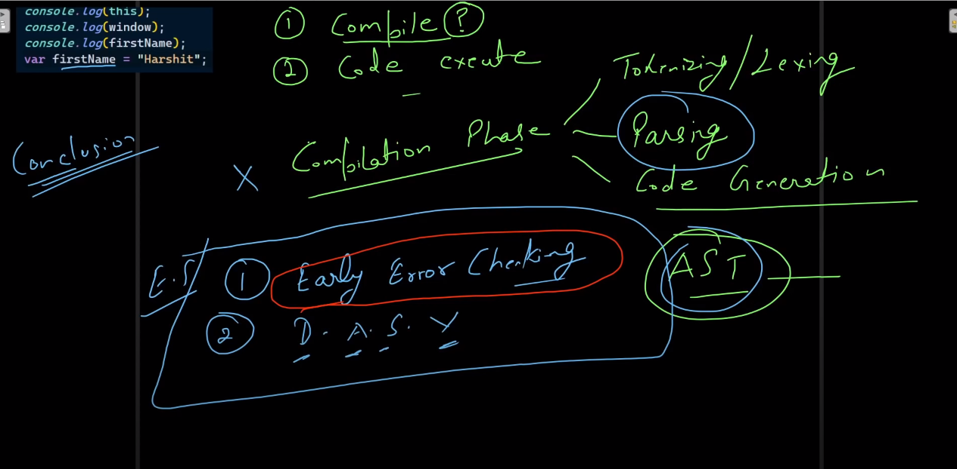

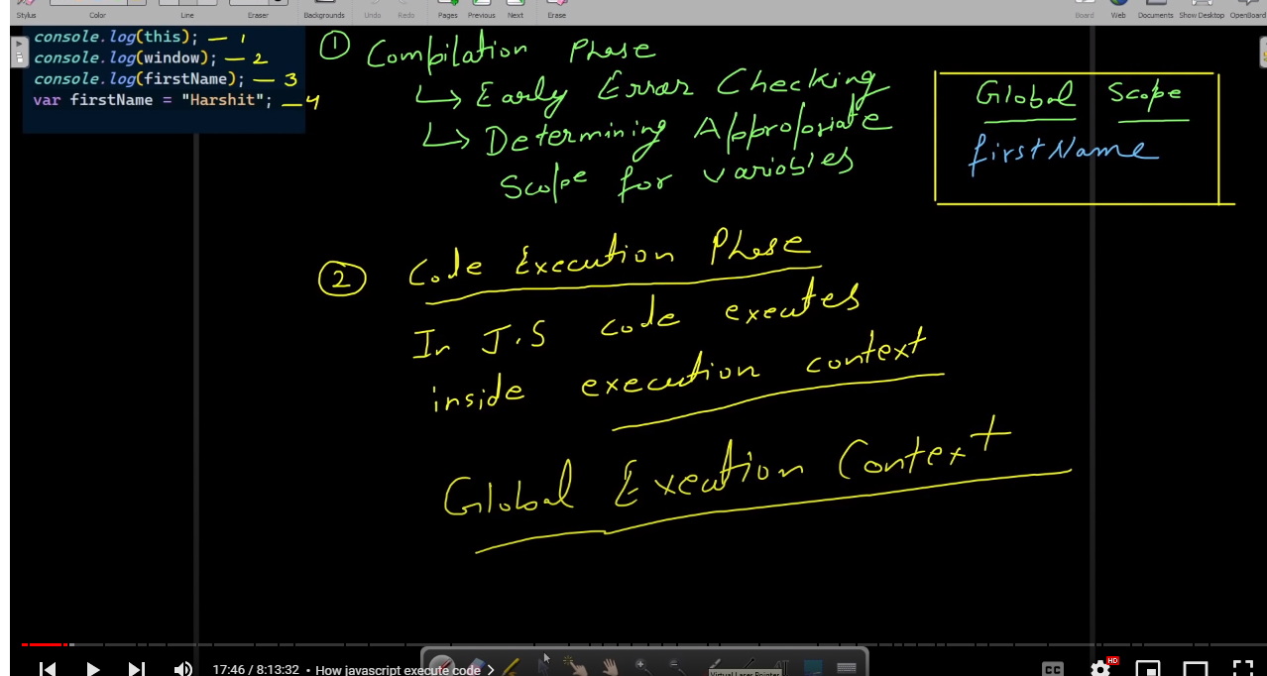

>sab sa pehla compile hoga program first image describe it

>code ko execute karna ka liya execution context create hoga

>or sab sa pehla jo execution context create hoga wo global execution context cerate hoga

> global execution context bhi do phase ma create hoga

1) creation phase(global memory)

2)code execution phase

>variables create hojata ha creation phase ka doran

>this ki value ko browser window set kardega(means this ma global object ki value save hojati ha at a time jo global object ho)

>var keyword ka case ma created variable ma undefine store hota ha creation phase ma

>synchronous means no other program will execute until the previous one completes

>and in asynchronous one or more programs can runs simultaneously they are independent of each other

>js is synchronous or single threaded means it read code line by line

>global execution ma var pehla hi define hojata ha matlab agr ham pehla console pa var ko call karen or wo variable declare bad ma hua hua ho .to jab ham usa pehla call karenga to wo error nahi dega balka agr ham var ko call karenga to usma undefined save hoga.like this

console.log(namessss);

var namessss = "lsklda"; //jab var use kar ka variable banay ga to undefined ay ga let or const ma kiya hoga wo agy ai ga

>compilation ka doran nbas ya pata lag jata ha ka var ha un ka pas balla wo var bad ma create hua ho

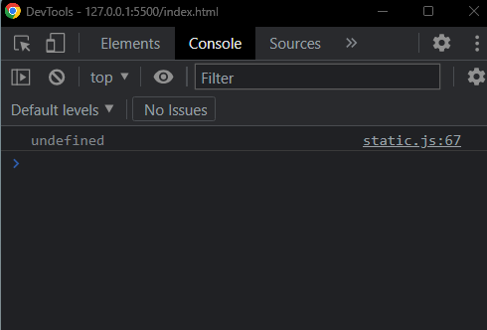

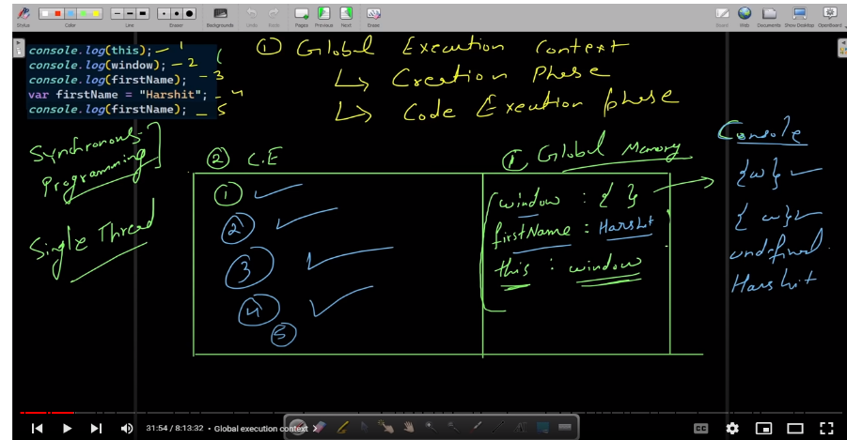

// compilation

// code execution

// why compilation

// How javascript code executes

// what is global exection context ?

// what is local execution context ?

// closures

console.log(this);

console.log(window);

console.log(firstName);

var firstName = "Harshit";

console.log(firstName);

* This and window in global execution context:

> agar this keyword kisi object ya fun sa bahar ho to wo us object ko call karega jo global ho yani jis ma hamara program chal raha ho ex: windows,browser,nodejs etc

>and window keyword window object batay ga

>global execution context stack ma banta ha

>and jab code execute hojata ha to wo gec ko stack sa pop out kardeta ha or us ka top par current execution context aa jata ha

* Hoisting:

>hoisting means code ka execute hona sa pehla var or func or propeties ko memory allocate hojati ha global memeory ma gec ka doran

>global execution do phase ma hoti ha

1.cretion phase (is ma ya hota ha ka agar jham poora program ma koi bhi var or func or properties define karta ha to wo initialize hojata ha kyunka jo bhi ham poora program ma function object etc jo bhi initialize karta ha wo global memory ma save hojata ha isi waja sa agar ham var ko pehla call kara or initialize bad ma kara to error nahin deta .error is liya nahi deta because wo creation phase ka doran global memry ma save hojata ha automatically js ma)

2.code execution phase (is phase ma code execute hota ha line by line or phir ham us ma var waghera ki value set karsakta ha)

>we can also call func before its initialization because in creation phase func is save in global memory(when we create function like this :function person(){} [if we make func in this way this is called func declaration])

// hoisting

console.log(this);

console.log(window);

console.log(myFunction);

console.log(fullName);

function myFunction(){

    console.log("this is my function");

}

var firstName = "Harshit";

var lastName = "Sharma"

var fullName = firstName + " " + lastName;

console.log(fullName);

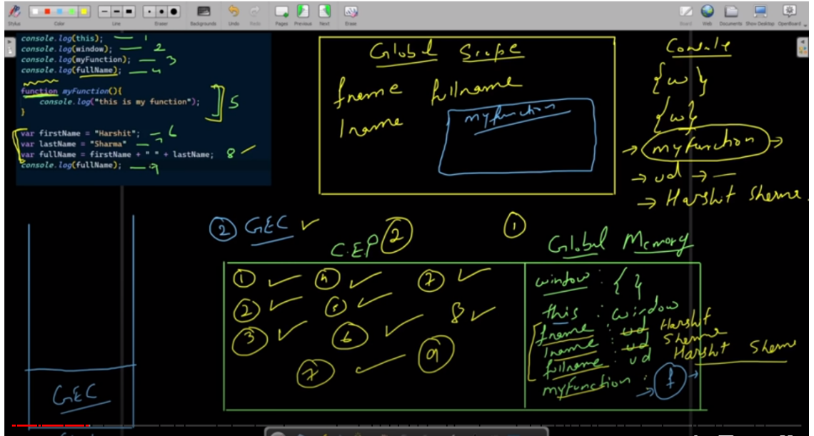

>gec of above code

* Are let and const are hoisted ? What is a reference Error ?:

>const and let are also histed like var

**Var:**

**>**in this case when line1 executes it will print undefinrd because when we use var to initialize name of var or func it will allocate memory at creation phase in globalbal memory. So, that why when we call my func before executing line2 it will return undefined because my func name var is defined in global memory but there is no value in it

console.log(myfunc); //line 1

var myfunc= function(){

    console.log("this is my function");

}

//method2

var myfunc; // we can also initialize first and then use in var

myfunc= function(){

    console.log("this is my function");

}

**Let & const:**

>when using var var are defifined it will return undefined because of global memery

As like this let and const are saved in global memory but they will return uninitialized(ui) error

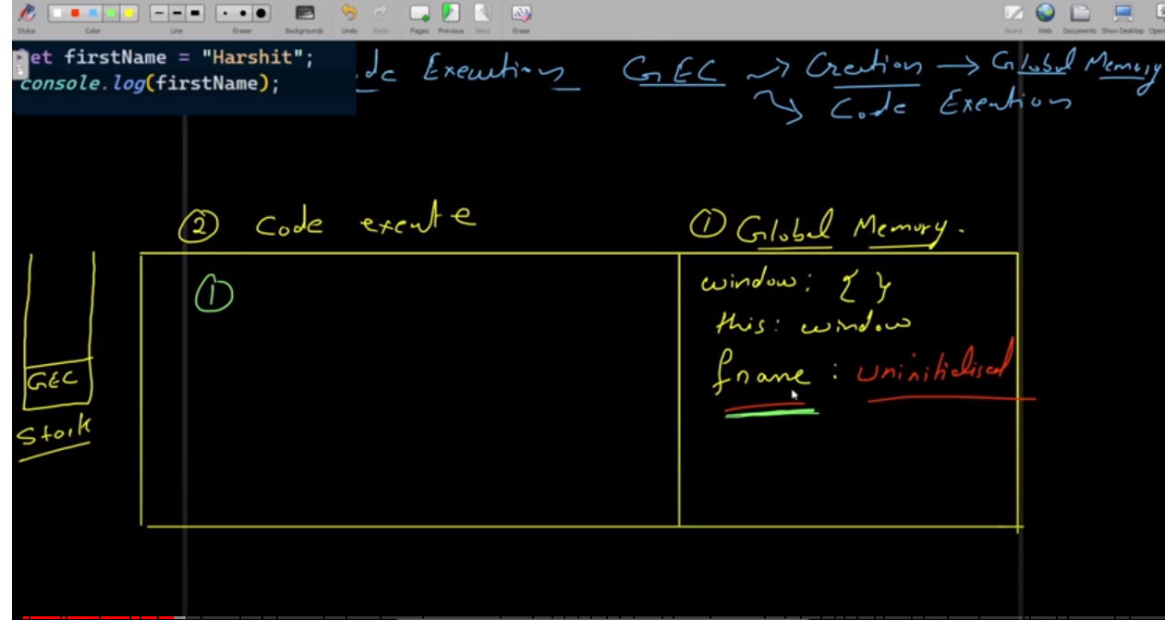

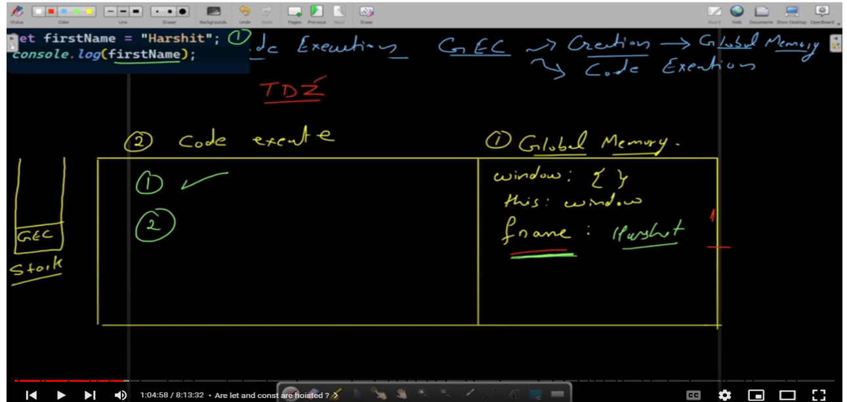

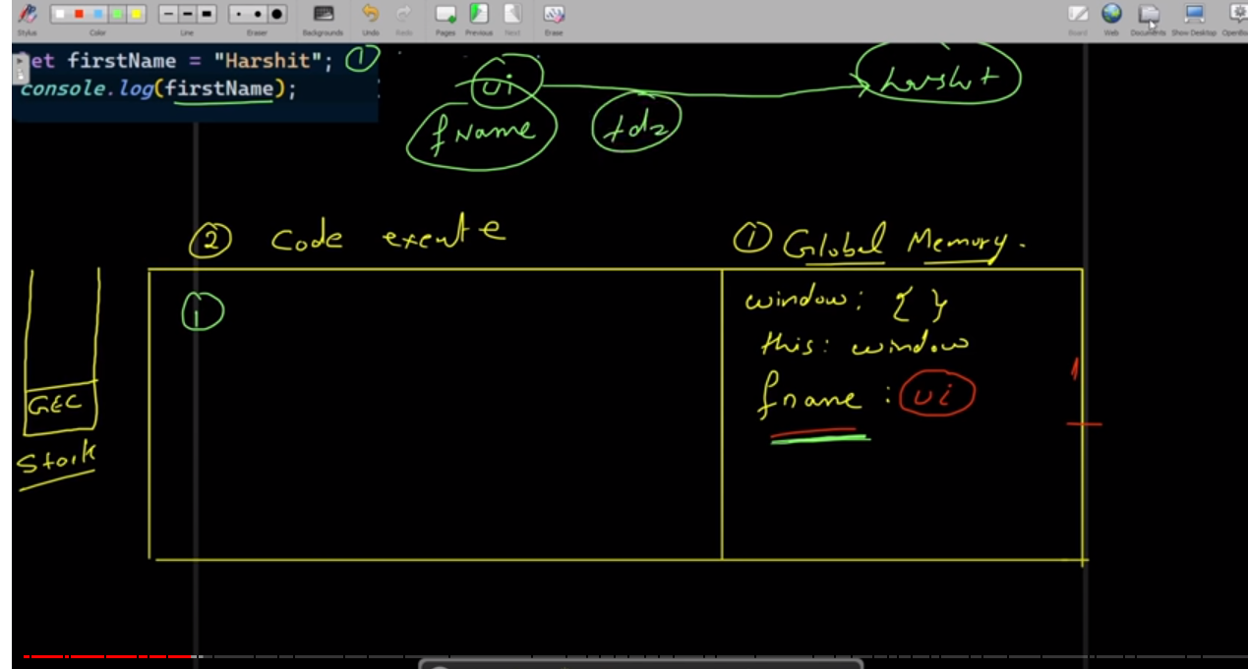

// let &const

// Uncaught ReferenceError:

// Cannot access 'firstName' before initialization

// Uncaught ReferenceError:

// firstName is not defined

// console.log(firstName);

// console.log(firstName);

// let firstName;  //we cannot do this in const

// console.log(firstName);

// console.log(typeof firstName);

// let firstName = "harshit";

**Revision of compilation or creation:**

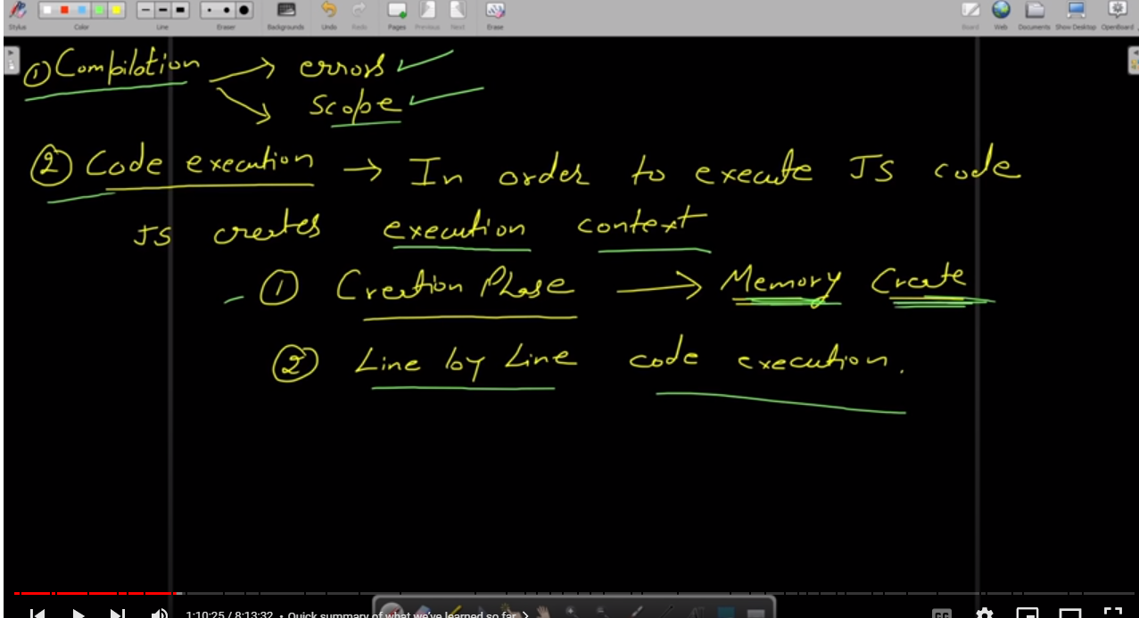

console.log("hello world");

let firstName = "Harshit";

let lastName = "Vashistha";

const myFunction = function() {

    let var1 = "First Variable";

    let var2 = "second Variable";

    console.log(var1);

    console.log(var2);

}

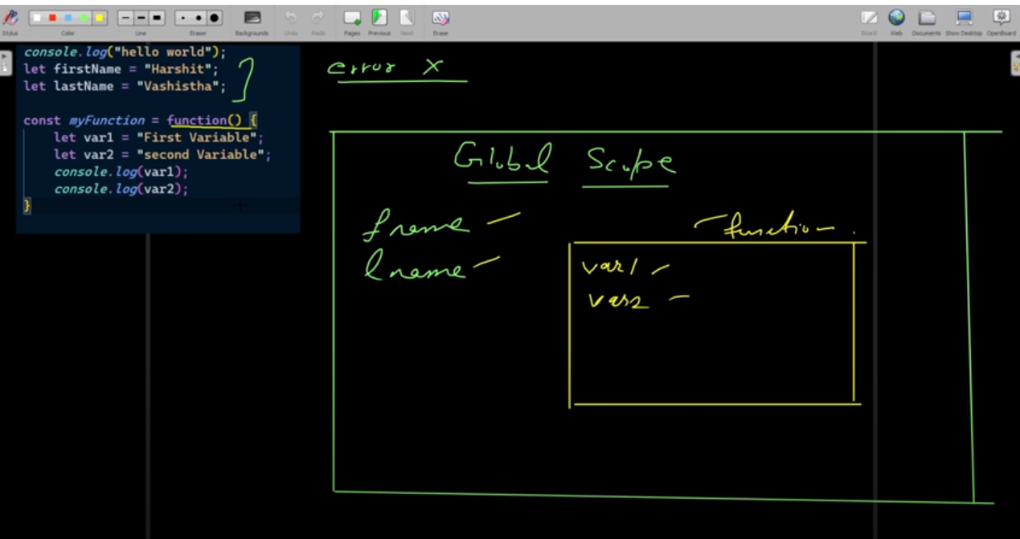

* Function execution context:

// function execution context

let foo = "foo";

console.log(foo);

function getFullName(firstName, lastName){

    console.log(arguments);

    let myVar = "var inside func";

    console.log(myVar);

    const fullName = firstName + " " + lastName;

    return fullName;

}

const personName = getFullName("harshit", "sharma");

console.log(personName);

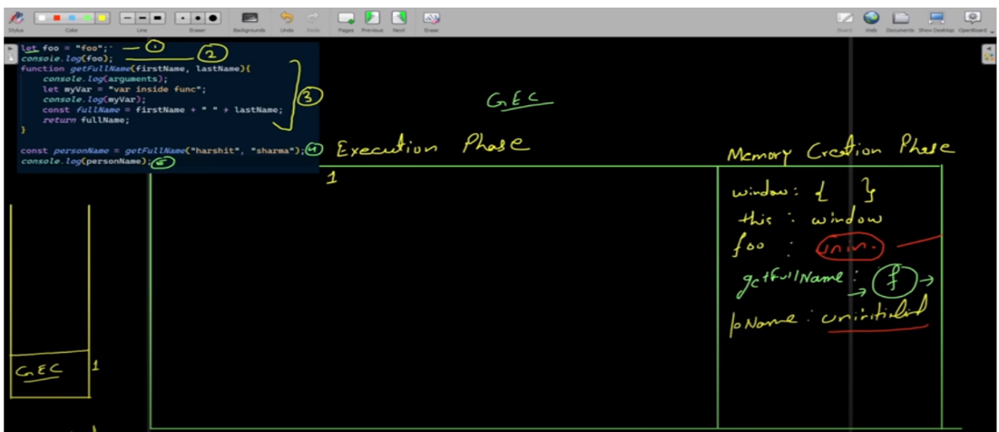

>memory creation phase for above code

>jab ham kisi execution context ka darmiyan koi func call karenga to us func ka liya lag execution context call hoga jo func execution context kehlay ga

>kyun ka upper wala program ma func ha to ab hama func ka alag sa execution context banana parega usma bhi wahi do same chezza hogi memory &code execution(line by line)

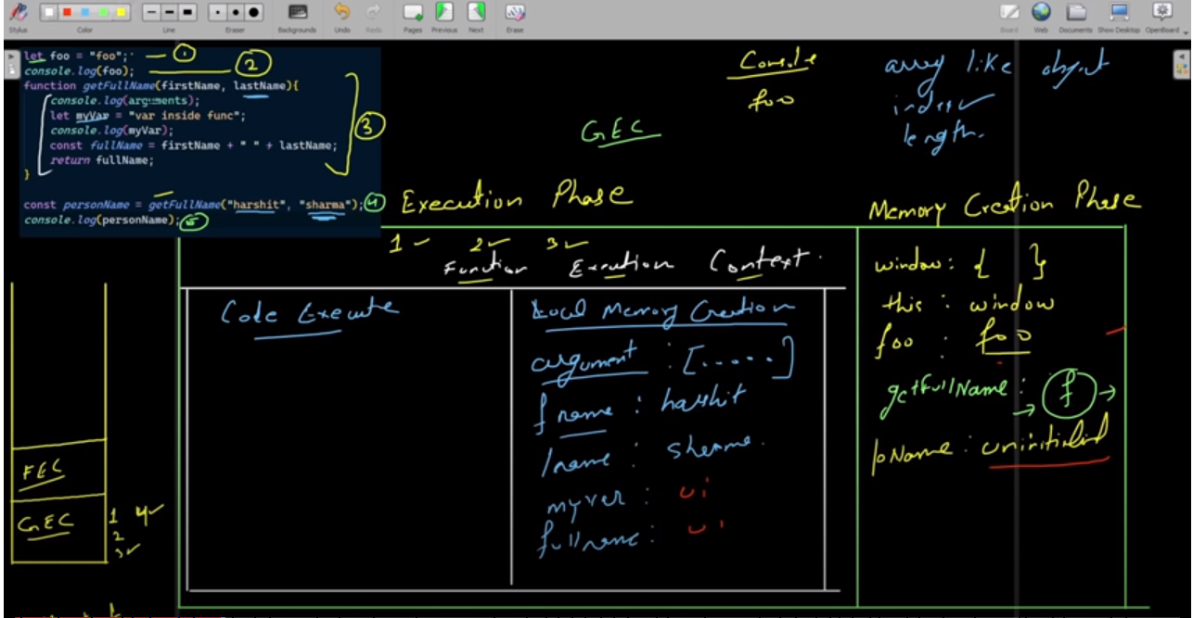

>func memory creation phase of above code

>stack ak andar bhi fec top par ajy ga jab fec khatam hoga to global execution start hogi

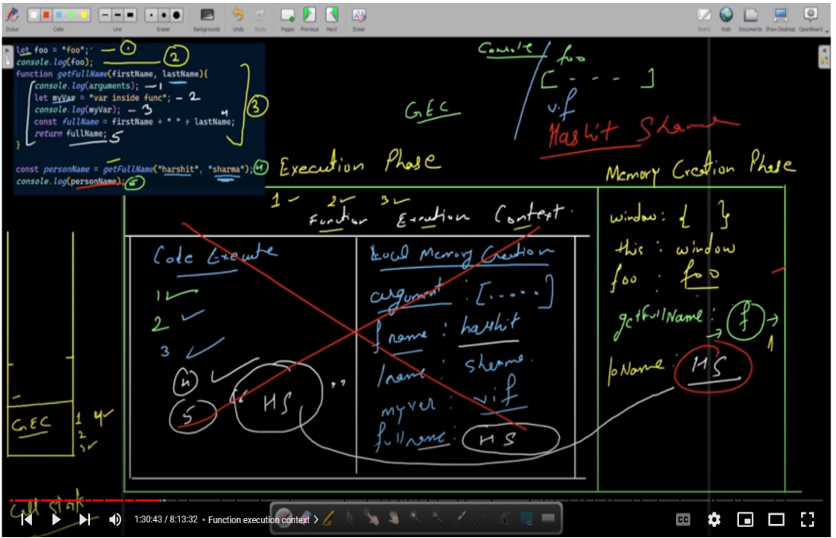>now tis is code execution phase for

* Fec and gec
* Scope chain and lexical environment:

// lexical environment, scope chain

const lastName = "Vashistha";

const printName = function(){

    const firstName = "harshit";

    function myFunction(){

        console.log(firstName);

        console.log(lastName);

    }

    myFunction()

}

printName();

>now we apply code execution on this code

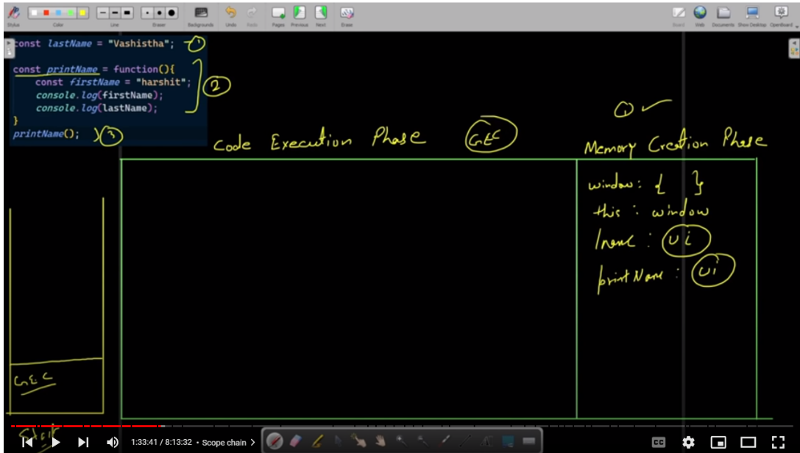

>memory creation phase in gec

>because there is a func in above code that’s why we will create fec for that func

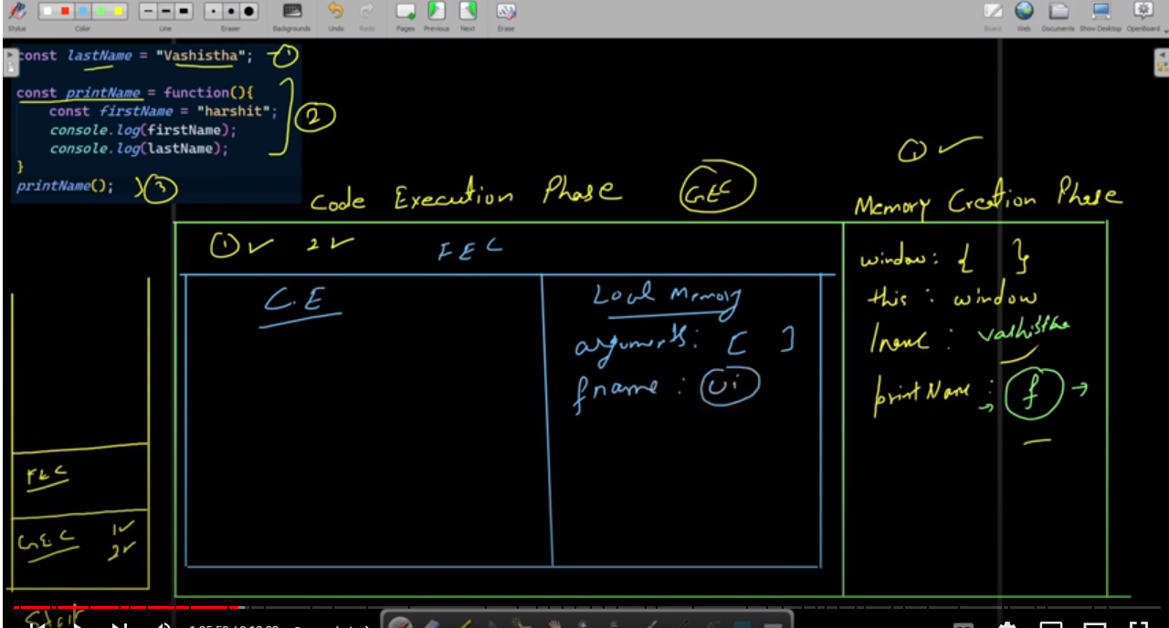

> memory creation phase in fec

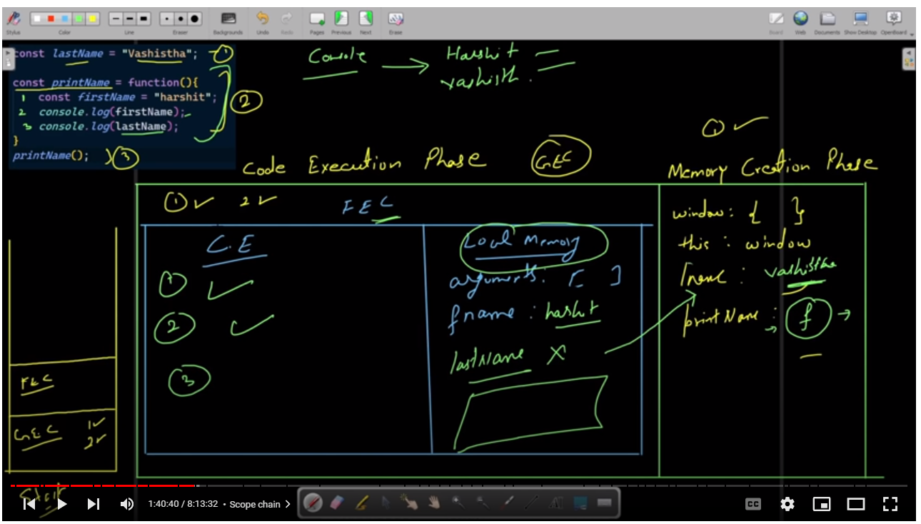

>ce for fec and gec

>if some property is not find in its own func local memory than it will find it in global memory(or where that func is present) or it is also called lexical environment for that property

* Intro to closures:

// closures

// closure : 30-40%

// analyse : 70-80%

// real example : 100%

// function can return functions

// function outerFunction(){

//     function innerFunction(){

//         console.log("hello world")

//     }

//     return innerFunction;

// }

// const ans = outerFunction();

// // console.log(ans);

// ans();

function printFullName(firstName, lastName){

    function printName(){

        console.log(firstName, lastName);

    }

    return printName; //when it is return it will return with firstName and lastName

}

const ans = printFullName("harshit", "sharma");

// console.log(ans);

ans();

>execution environment of above code

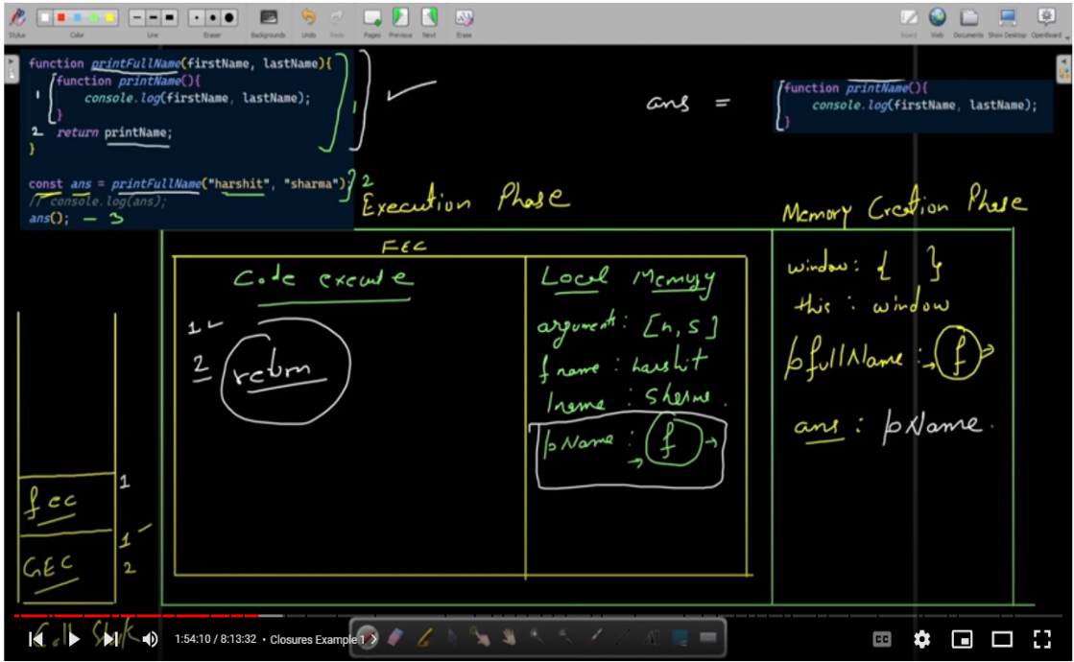

>in this fec is printFullName

>in this fec is 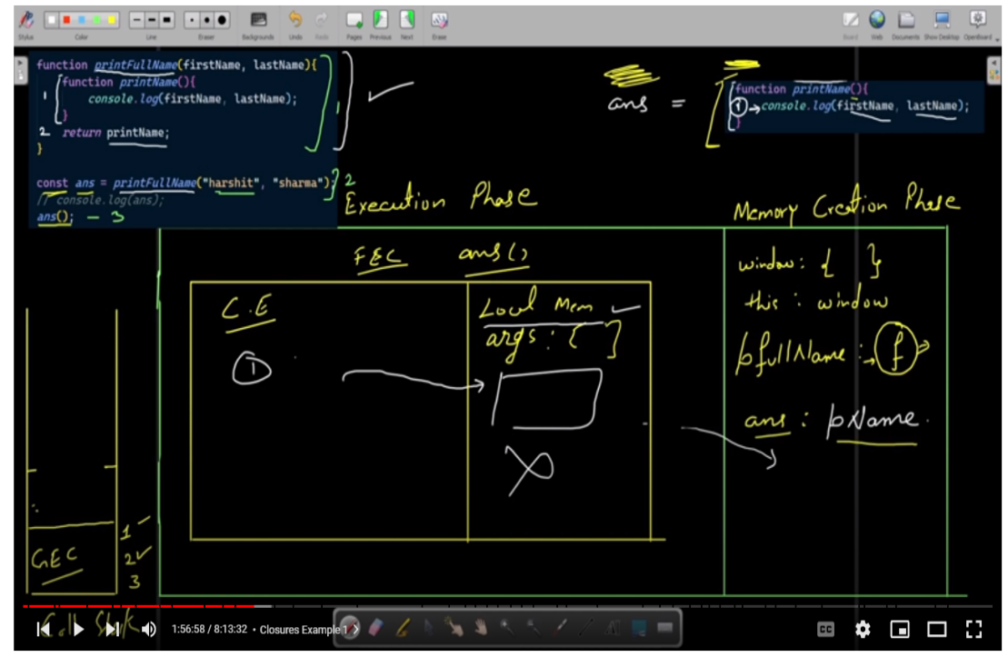printName which is present in ans variable line 3 green color

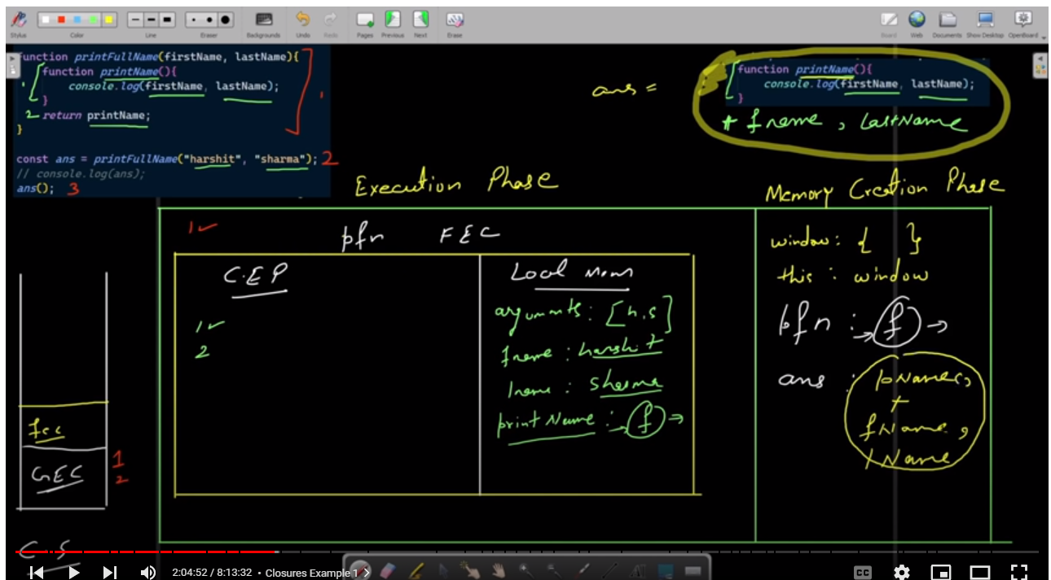

>complete execution

>remember that if there is a function inside a func than inside func will also have all the var or func of its lexical environment means var or func of its outer function .

* Closure example 1:

function hello(x){

    const a  = "varA";

    const b = "varB";

    return function(){

        console.log(a,b,x);

    }

}

const ans = hello("arg");

ans();

>now we will analyze this example

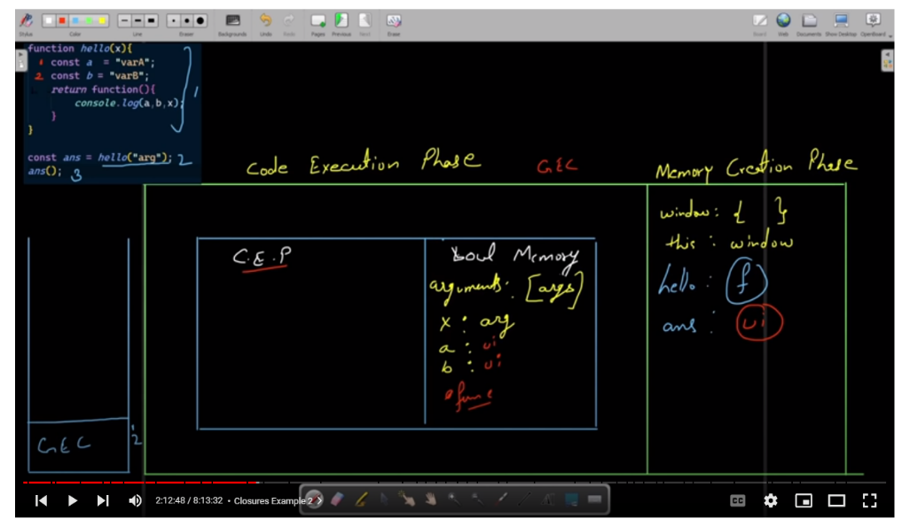

>ocal memory for hello()

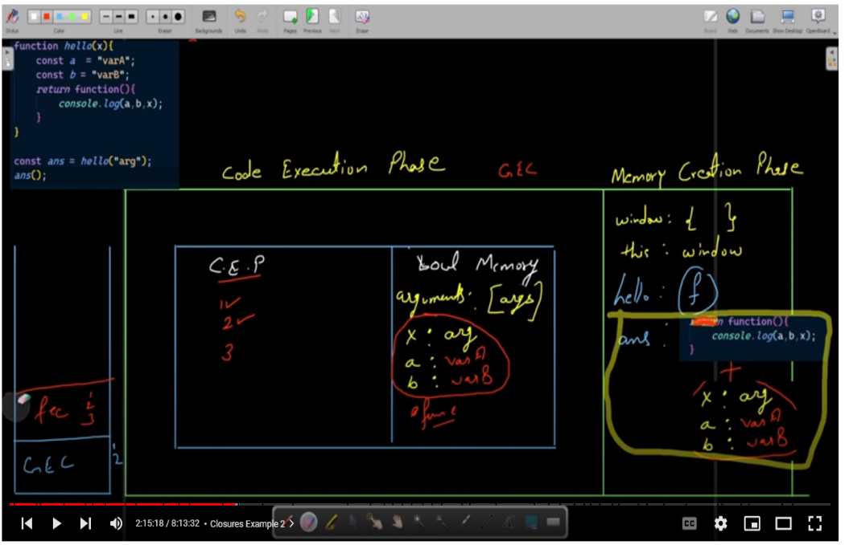>code execution for hello() which is returning function(){

Console.log(a,b,x);

} + variables of hello() functions . lexical environment for this func ;

function(){

Console.log(a,b,x);

}

Is hello()

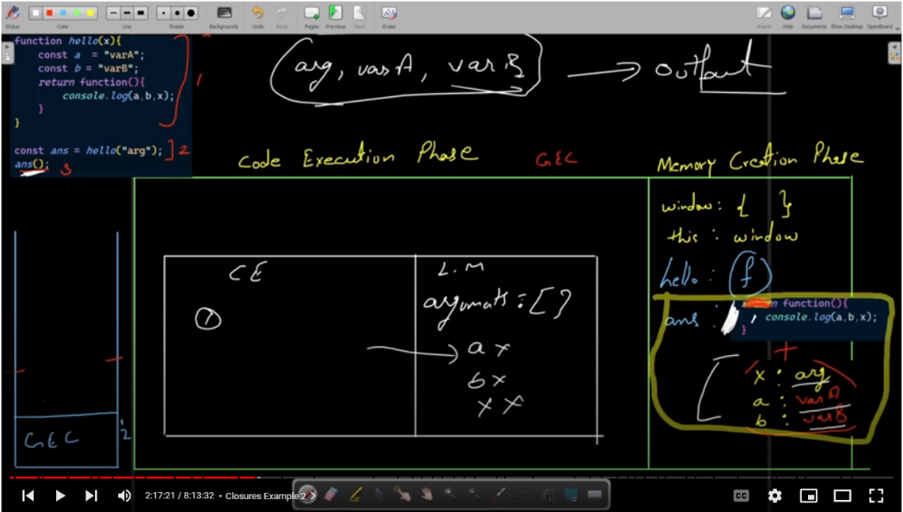

>executing last line of global ans(),which is calling this fun;

function(){

Console.log(a,b,x);

}

* Closure Example 2:

// function myFunction(power){

//     return function(number){

//         return number ** power

//     }

// }

// const square = myFunction(2);

// const ans = square(3);

// console.log(ans);

// const cube = myFunction(3);

// const ans2 = cube(3);

// console.log(ans2);

function myFunction(power){

    return function(number){

        return number ** power

    }

}

const square = myFunction(2);

const ans = square(3);

console.log(ans);

const cube = myFunction(3);

const ans2 = cube(3);

console.log(ans2);

// //my code

// function power(p) {

//     return function (no) {

//         return no**p

//     }

// }

// const sq = power(2);

// const ans = sq(4)

// console.log(ans);

// const pow = p =>no => no**p

// const cube = pow(3)

// const ans2 = cube(3);

// console.log(ans2);

>now we will analyze this example

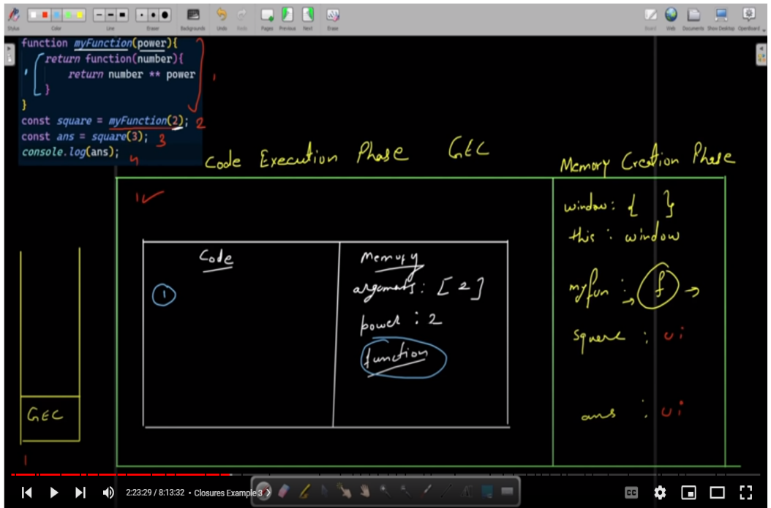

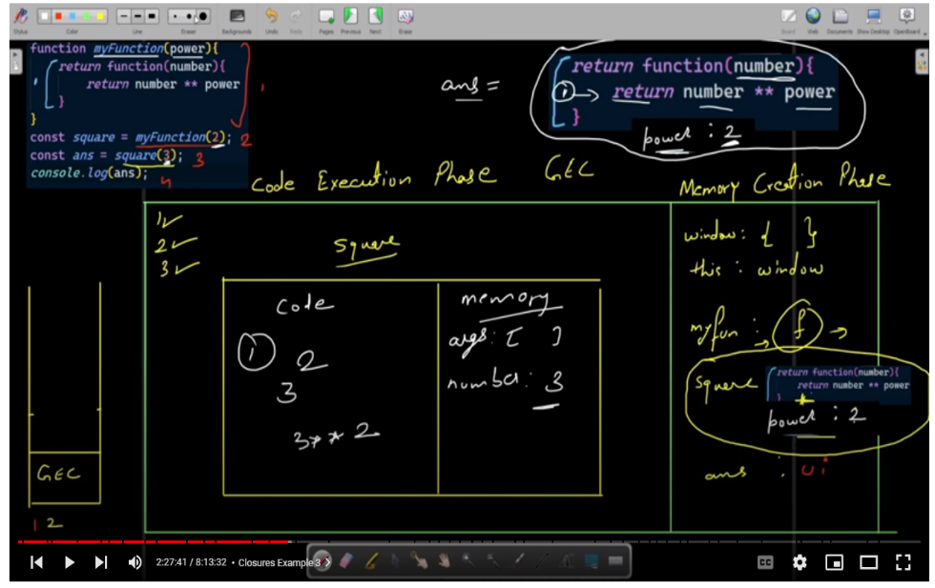

* Closure Example 3:

function func(){

    let counter = 0;

    return function(){

        if(counter < 1){

            console.log("Hi You Called me");

            counter++;

        }else{

            console.log("Mai already ek bar call ho chuka hoon!");

        }

    }

}

const myFunc = func();

myFunc();

myFunc();

// //my code

// function func() {

//     let i = 0;

//     return function () {

//         if (i === 0) {

//             i++;

//             console.log("shehroz");

//         }else{

//             console.log("alredy called");

//         }

//     }

// }

// const myFunc = func();

// myFunc();

// myFunc();

// const myFunc2 = func();

// myFunc2();

// myFunc2();

>now we will analyze this example

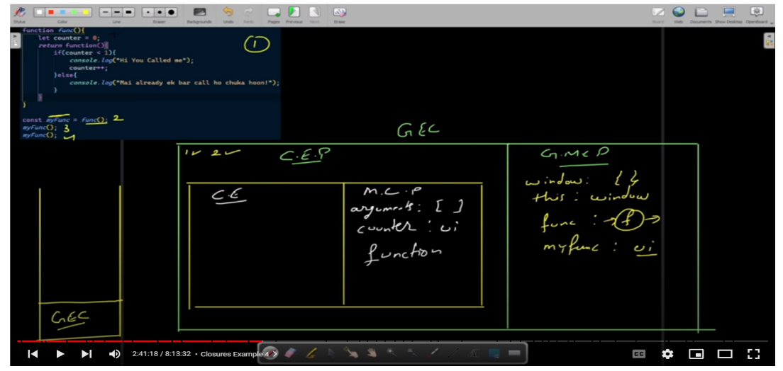>this fec for func()

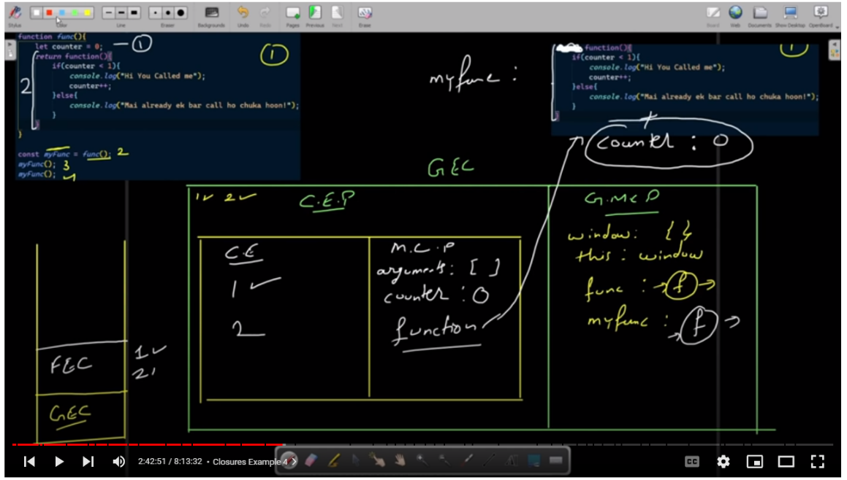>this is returninf func in line 2 yellow color

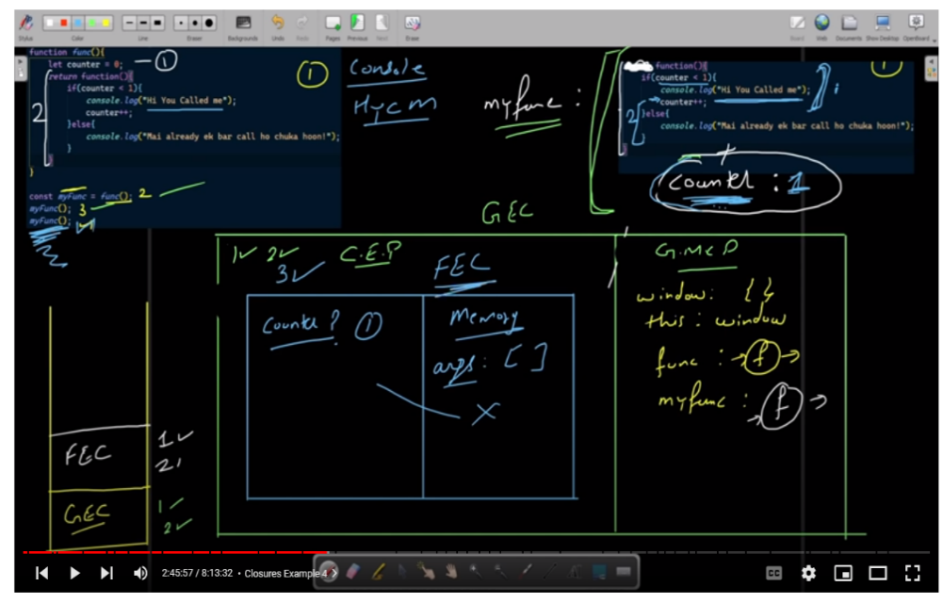>this fec for myfunc line 3

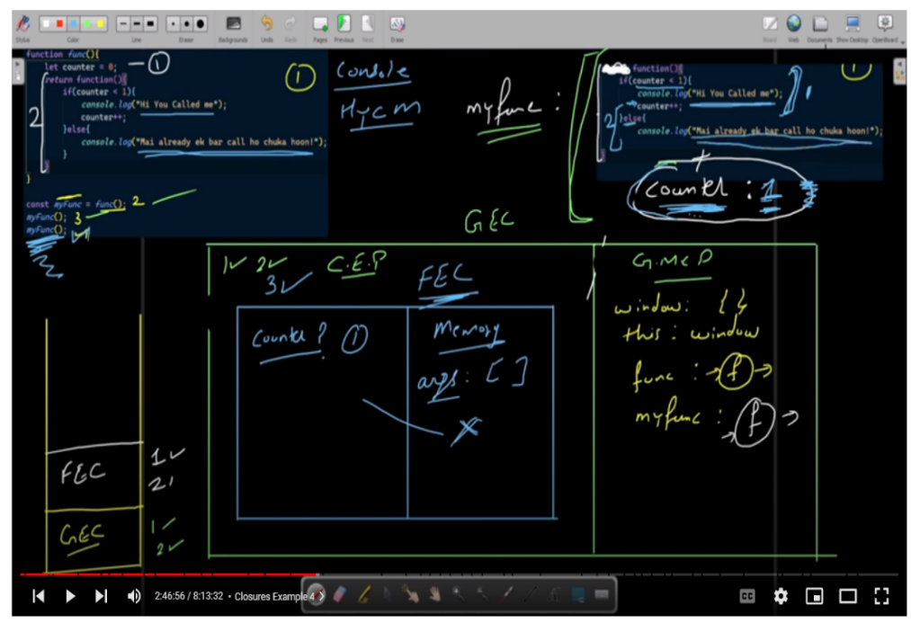

>this fec for myfunc line 3 as we are calling my func 2nd time

DOM Tutorial

* HTML and CSS Crash course ( Around 30-40 minutes):

>html:

<!DOCTYPE html>

<html lang="en">

<head>

    <meta charset="UTF-8">

    <meta http-equiv="X-UA-Compatible" content="IE=edge">

    <meta name="viewport" content="width=device-width, initial-scale=1.0">

    <link rel="stylesheet" href="./style.css">

    <title>My website</title>

</head>

<body>

    <header class="header">

        <nav class="nav container">

            <h1 class="logo"> website</h1>

                <ul class="nav-items">

                    <li><a href="">home</a></li>

                    <li><a href="">todo</a></li>

                    <li><a href="">signup</a></li>

                </ul>

        </nav>

        <div class="headline">

            <h2>Manage your task</h2>

            <button class="btn btn-headline">Learn more</button>

        </div>

    </header>

    <section class="section-todo container">

        <h2>your plan for today:</h2>

        <form class="form-todo">

            <input type="text" name="" id="" placeholder="Add todo">

            <input type="submit" value="Add Todo" class="btn">

        </form>

    </section>

    <section class="section-signup container">

        <h2>Sign up</h2>

        <form class="signup-form">

            <div class="form-group">

                <label for="username">Username</label>

                <input type="text" name="username" id="username">

            </div>

            <div class="form-group">

                <label for="password">Password</label>

                <input type="text" name="password" id="password">

            </div>

            <div class="form-group">

                <label for="confirmPasword">Confirm Pasword</label>

                <input type="text" name="confirmPasword" id="confirmPasword">

            </div>

            <div class="form-group">

                <label for="phone">Phone</label>

                <input type="text" name="phone" id="phone">

            </div>

            <div class="form-group">

                <label for="email">Email</label>

                <input type="text" name="email" id="email">

            </div>

            <div class="form-group">

                <label for="about">About yourself</label>

                <textarea name="about" id="about" cols="30" rows="10"></textarea>

            </div>

            <button type="submit" class="btn">Submit</button>

        </form>

    </section>

</body>

</html>

>css:

 @import url('https://fonts.googleapis.com/css2?family=Poppins:wght@200;300;400;500;600;700&display=swap');

*{

    box-sizing: border-box;

    padding: 0;

    margin: 0;

}

 body{

    font-family: 'Poppins', sans-serif;

}

a{

    text-decoration: none;

    color: rgb(17, 192, 192);

}

.header{

    position: relative;

    min-height: 60vh;

    /* background: grey; */

    background: url("./img.png");

    background-position: center;

    background-repeat: no-repeat;

    background-size: cover;

    color: aliceblue;

}

.container{

    max-width: 1200px;

    margin: auto;

    width: 90%;

}

.nav{

    min-height: 8vh;

    display: flex;

    justify-content: space-between;

    align-items: center;

}

.nav-items{

    width: 40%;

    display: flex;

    list-style-type: none;

    justify-content: space-between;

}

.headline{

    text-align: center;

    position: absolute;

    top: 50%;

    left: 50%;

    transform: translate(-50%,-50);

}

.btn{

    display: inline-block;

    outline: none;

    border: none;

    cursor: pointer;

}

.btn-headline{

    padding: 1rem 2rem;

    font-size: 1rem;

    margin-top: 1rem;

    font-weight: 600;

}

.section-todo{

    margin-top: 5rem;

    text-align: center;

}

.form-todo{

    min-height: 5vh;

    display: flex;

    justify-content: space-between;

    margin-top: 1rem;

}

.form-todo input{

    min-height: 100%;

}

.form-todo input[type = "text"] {

    width: 78%;

    padding: 0.8rem;

    font-size: 1rem;

    font-weight: 400;

}

.form-todo input[type = "submit"] {

    width: 20%;

    background: rgb(44, 55, 63);

    color: white;

    font-weight: bold;

}

.section-signup{

    margin: 5rem auto;

    text-align: center;

    background: rgb(196, 188, 188);

    border-radius: 10px;

    padding: 1rem;

}

.signup-form{

    max-width: 800px;

    width: 95%;

    text-align: left;

    margin: auto;

}

.signup-form label{

    display: block;

}

.signup-form input{

    display: block;

    width: 100%;

    padding: 0.5;

}

.form-group{

    margin-top: 1rem ;

}

.signup-form textarea{

    width: 100%;

}

.signup-btn{

    background: rgb(44, 55, 63);

    color: white;

    padding: 1rem 2rem;

    display: block;

    margin: auto;

    margin-top: 1rem;

}

* Async vs defer(how to connect js with html):

>**async:** means parsing(line by line reading) of html file and loading of js file will run simultaneously

>in async keyword parsing will stop when loading of js file wil complete and then js file try to execute that file which result in halt of parsing html file due to which there are chances of error occurrence with using async keyword because half html file is loaded and half is still remained

    <script src="async_or_differ.js" async></script>

>**differ:** in this method parsing(html) and loading(js) runs parallel and when loading of js is complete it will not execute js until whole html file got parsed.it is time saving method

    <script src="async_or_differ.js" defer></script>

// DOM

// document object model

// overview

// how to use

// deep study

// console.dir(document);//agar js jesa dikhana hoto dir likho agar html jesa to phir log

>jo bhi ham file banata ha htmla ki wo window ka object ka andar document name ki key madd hojata ha

* Select elements using id:

>in html we have given id to headings through this id we can access that headings

//my code

// console.log(typeof document.getElementById("main-heading"));

const id = document.getElementById("main-heading");

console.log(id);